|  |  |  |  |
| --- | --- | --- | --- |
| **Project Title:** | Amyvid™ Online Reader Training Web Site 2.0 | | |
| **Job #/PO:** | 5697 | | |
| **Project Lead:** | Valerie McGovern | | |
| **Prepared by:** | Valerie McGovern | Date, Version #: | 4/11/17 v.9 |

KEY

Yellow Highlighted Text = Information is pending/being confirmed

Red text = Most recent Avant changes

Blue text = Most recent Hibbert changes

Revision History

|  |  |  |  |
| --- | --- | --- | --- |
| **Name** | **Date** | **Version** | **Changes** |
| Brittany Stiles | 11/14/16 | v1 | * Created document |
| Val McGovern & Frank D’Errico | 11/18/16 | v1 notes | * Added notes/feedback/additional requirement specs |
| Brittany Stiles | 11/21/16 | v2 | * Removed ability to link from 3rd party site from “Out of Scope” section and added to “Assumptions and Constraints” section since we do need this capability * Added use case flow to discuss Interstitial, Login, Training Access navigation for Live Reader Training users (TBD) * Removed Contact Us page requirements * Changed Ask Lilly references to now be oriented toward the Amyvid-specific contact number * Submit a Request or Chat functions from Ask Lilly feature removed/disabled * Revised Main Landing Page header content/wire-frame * Revised User Account Subheader content/wire-frame * Added detail for new “Resource Center” navigation and content (full details and wire-frames still TBD/added) * Removed Live Reader Training content from Landing Page * Detailed new section for FIA file load exchange and user account management rules * Added content outline for About Amyvid and Patient Case Study areas (specific content TBD/being developed) * Added clarification on “Remember Me” login functionality to note may only be able to do so for username ~~(MLR consult)~~ * Removed “Title” field from registration and My Profile Edit fields * Added clarification to use CCR approved specialty list when sourcing the Primary Specialty drop-down in both the Registration and My Profile Edit fields * Added JS functions into Bookmarking/Tracking Functionality area for THG documentation * ~~Added need for survey content/navigation edits per need for survey Q’s after modules 4 and/or 5~~ * Removed 5 day reminder email |
| Brittany Stiles | 2/01/17 | v3 | Complete revision of requirements per final specs |
| Brittany Stiles | 2/03/17 | v4 | * Fixed all within-doc section hyperlink references * Updated Browser Requirements * Added missing screenshots for Change Information/Change Password Pages * Removed extraneous requirement under About Amyvid that no longer applies * Removed item for New Content emails – as these will be handled by Area 23 |
| Valerie McGovern | 3/2/17 | V5 | * Updated Assumptions and Constraints for LRT profiles * Updated Survey Business Rules to require Rate Training button to persist and allow users to complete survey multiple times * Removed Survey Business Rule that survey will be added at the end of Module 5 and Module 5 * Added Alternate User Flow for Access via LRT E-mail links section and Business Rules * Updated Module Player Mark Complete Functionality Business Rules to reflect that only Module 3 will have a Mark Complete button and added screenshot * Revised Survey Response Report metrics to reflect updated survey questions |
| Frank D’Errico | 3/23/2017 | V6 | * Updates to section D and E for Reporting and Admin Portal consisting of Lookup Tool and Analytics |
| Valerie McGovern | 3/27/17 | V7 | * Updated Navigation Actions and screenshots to reflect Phase 1 revisions for Homepage and ISI Container * Updated Module Player   + Navigation Actions   + Course Progress Menu section   + Reference List section * Added Modules 1 & 2 Business Rules and Navigation Actions * Updated Survey Business Rules and Navigation Actions |
| Valerie McGovern | 3/28/17 | V7.1 | * Updated screenshots to reflect Phase 1 revisions for About Amyvid, and Login Modal * Updated Survey Business Rules and Navigation Actions |
| Valerie McGovern | 3/31/17 | V8 | * Added Modules 3 & 5 Business Rules, Navigation Actions, and Error Messages * Added Navigation Actions and Error Messages for Module 2 * Updated Business rules for Modules 1 & 2 |
| Valerie McGovern | 4/11/17 | V9 | * Updated Business Rules for Module 2 and added Screen Mockups * Updated Business Rules for Module 3 * Updated Business Rules for Module 5 and added Navigation Action |

**Contents**

A. Project Overview 4

A.1 Project Contacts 4

A.2 Purpose/Objectives 4

A.3 Business Needs 4

A.4 Assumptions and Constraints 5

A.5 Out of Scope Functionality 6

B. Functional Requirements 6

B.1 Overall Site 6

B.1.1 Feature: HCP Interstitial 6

B.1.2 Feature: ISI Container Display 8

B.1.3 Feature: Locked Top Site Header 11

B.1.4 Feature: Site Footers 12

B.1.5 Feature: Navigation Header for Main Pages 13

B.1.6 Feature: Maintenance Outage Page 14

B.1.7 Feature: Error Page 14

B.2 Main Site Pages 15

B.2.1 Feature: Home Page 15

B.2.2 Feature: About Amyvid Page 17

B.2.3 Feature: Patient Case Studies Page 20

B.2.4 Feature: Reader Training Page 26

B.3 User Account-Based Pages 29

B.3.1 Feature: FIA Load Process and User Account Management 29

B.3.2 Feature: Sign In Modal 29

B.3.3 Feature: Forgot Password Request Page 32

B.3.4 Feature: Forgot Password Sent Page 34

B.3.5 Feature: Registration Page 34

B.3.6 Feature: Registration Thank You Page 39

B.3.7 Feature: My Profile Page 40

B.3.8 Feature: Sign Out Modal 41

B.3.9 Feature: View/Print Certificate Modal 42

B.3.10 Feature: My Profile – Change Information Page 43

B.3.11 Feature: My Profile – Change Password Page 44

B.3.12 Feature: Profile Updated Modal 45

B.3.13 Feature: Core Training Complete/Survey Page 47

B.4 Within Module Features 50

B.4.1 Feature: Module Player Page 50

B.4.2 Feature: Module Player – Resume and Exit Prompts 52

B.4.3 Module Player – Mark Complete Functionality 53

B.4.4 Module Player – Course Progress Menu 53

B.4.5 Module Player – Reference List 54

B.4.6 Bookmarking and Tracking Functionality 55

B.4.7 Feature: Module Content 56

C. Site-Related Emails 58

C.1.1 3 Day Email Reminder 58

C.1.2 7 Day Email Reminder 58

~~C.1.3~~ ~~Email Blast for New Content~~ 58

C.1.4 Welcome/New Registration E-mail 58

C.1.5 Forgotten Password Email 59

C.1.6 Core Training Complete/Certificate Email 59

D. Site Metrics/Reporting 60

D.1.1 Feature: Reader Training Completion Report 60

D.1.2 Feature: Module Tracking Report 62

D.1.3 Feature: Survey Report 63

D.1.4 Feature: Email Report 64

D.1.5 Feature: Enhanced Integration for Reporting 65

D.1.6 Feature: Live Agent Technical Support Report 65

E. Non-Functional Requirements 66

E.1 Hardware and Software Support Environments 66

E.1.1 Browser/Operating System Constraints 67

E.2 Tablet Compatibility 67

E.3 Performance 67

E.4 Security and Compliance 67

E.5 Usability 67

E.6 System Interaction 67

F. Review and Approvals 67

# Project Overview

## Project Contacts

| Client: (List each person who will use the deliverables produced by the project) | | | | | |
| --- | --- | --- | --- | --- | --- |
| Name | Department | Title | Telephone | E-mail | |
| Sarah Foster | Amyvid | Associate Brand Manager, Amyvid | 317.277.9078 | [foster_sarah_elizabeth@lilly.com](mailto:foster_sarah_elizabeth@lilly.com) | |
| THG Contacts: (List key project stakeholders who have a key interest in the project) | | | | | |
| Name | Department | Title | Telephone | | E-mail |
| Frank D’Errico | IT | Business Analyst | 609.222.6152 | | [fd’errico@hibbertgruop.com](mailto:mkerr@hibbertgroup.com) |
| Hussain Moochalla | IT | Director | 609.222.6452 | | [hmoochalla@hibbertgroup.com](mailto:hmoochalla@hibbertgroup.com) |
| Jill Nolan | Sales | Senior Account Executive | 609.947.5012 | | [jnolan@hibbertgroup.com](mailto:jnolan@hibbertgroup.com) |
| Avant Contacts: (List key project stakeholders who have a key interest in the project) | | | | | |
| Name | Department | Title | Telephone | | E-mail |
| Valerie McGovern | Digital Project Management Office | Senior Digital Project Manager | 317.569.6702 | | valerie_mcgovern@avanthc.com |
| ~~Brittany Stiles~~ | ~~Technology Services~~ | ~~Business Analyst~~ | ~~317.208.3659~~ | | ~~brittany_stiles@avanthc.com~~ |

## Purpose/Objectives

The purpose of the **AmyvidOnline Reader Training (ORT)**siteis to reach healthcare professional (HCP) customers with educational content that can be accessed digitally. The site serves to build HCPs’ confidence in interpreting and reporting an Amyvid™ scan by providing an online educational resource for educating HCPs on amyloid’s role in the diagnostic process and the value of knowing patients’ amyloid status. This tool is to not only be a source of reader training certification, but to be an ongoing/overall HCP resource for important information regarding Amyvid.

## Business Needs

* Provide industry-leading customer experiences to HCPs by creating a seamless and easy interactive HTML platform to house Amyvid Reader Training content digitally
* Host and manage modules and registration database for the Amyvid ORT program, including reporting on HCP activity via bookmarking, survey responses, question/answer, correct/incorrect responses, call center support, certificate of completion and reporting
* Reach HCP customers with interactive content that can be easily accessed via Web, as well as utilized by the field as a potential detailing resource
* Create a site that can serve as not only a forum for ORT, but also as an HCP resource for Amyvid-related content that clearly communicates messaging behind the “5 pillars” concept:
  1. Establish the problem of misdiagnosis
  2. Establish the amyloid biomarker
  3. Establish the tool
  4. Establish the tool’s benefits
  5. Establish the availability
* Design a landing page layout that improves bounce rates by providing clear call-to-action areas and information that communicates to users what they’re going to get out of the site

## Assumptions and Constraints

* The ORT site has the following capabilities included in scope:
  + Account Registration
  + Host HTML Modules for Training Content
  + Book Marking
  + Use Case/Knowledge Check Data Capture
  + Certification
  + Reminder Emails
  + Monthly Reporting
  + Database Integration
  + Survey
* All Lilly CIQ guidelines will be adhered to.
  + References to CIQ guidelines in this document are not to be considered replacements for official Lilly CIQ documents. All site content must comply with current Lilly CIQ policies
* Users must confirm they are HCPs prior to accessing the ORT site
* All Amyvid branding guidelines from Area 23 will be consulted for required design elements to ensure consistency
* The site will utilize vanity URLs of: [www.amyvid.com](http://www.amyvid.com), [www.amyvidhcp.com](http://www.amyvidhcp.com), amyvidtraining.com
* All developmental design and associated assets will be created by Avant, in consultation with The Hibbert Group (THG) and Area 23
  + It is assumed that Avant will consult with THG on all requirements to confirm alignment on functionality prior to development of those requirements
  + It is assumed that Avant will consult with Area 23 on all design assets to confirm alignment on brand guidelines prior to development of those assets
  + It is assumed that THG will host the ORT site and will assemble/configure site assets that Avant develops and provides
  + It is assumed that once site assets (eg, HTML, CSS, JS plugins, images, other hosted files) are provided by Avant to THG, that THG and Avant will share ORT site testing responsibilities—however, it is assumed that all assets Avant provides will have been independently QC’ed prior to providing to Hibbert
* Site should allow for easy updating to add, remove or replace presentations
* There will not be an administrative interface for the ORT site, Hibbert will be responsible for developmental updates per SLA agreement with Avant
* Communications related to marketing efforts outside of the ORT site functionality will not be included in this scope. Only emails described within this FRD’s “Site-Related Emails” section will be considered in-scope for the site.
* Users must log-in with their Amyvid ORT account username/password–users will have accounts created via the following methods, but all accounts should be tracked/managed together:
  + Previous ORT v1.0 accounts
  + Livereader training (LRT) certification accounts from 2017 live programming (created/confirmed for participant via post-program communication that includes copy of LRT certificate)
    - Will need Avant to review records so information sent in FIA is legible/valid prior to file exchange
    - Hibbert will perform standard data validation and de-dupe
  + New ORT v2.0 accounts
* Creation and management of online accounts for Live Training users prior to 2017 will be included and completed by Hibbert pending source files from the brand team
* Links to Important Safety Information (ISI), Prescribing Information (PI), Privacy Information, Terms of Use, and Copyright must be displayed on all site pages
* Users should not be able to download video content directly to the user’s local machine or print the video content from the site to ensure both CIA/Regulatory compliance and approved content
* Site must be iPad compatible and optimized for viewing on iPad
* Site must be compatible with major web browsers [See Non-Functional Requirements for more details]
* Must have a user friendly error page in the event site is no longer available.
* Allowing third party sites/URLs to link to this site needs to be a capability in case we have future 3rd party banner ads or emails driving users to the site in the future

## Out of Scope Functionality

* No user table – Access control will be facilitated via accessing the existing Online Reader Training database owned and managed by Hibbert
* Administrative interfaces for upload of content are not included in this version of the application
  + Hibbert will modify any additions/changes on the back-end
* Detailed security model
* Video content within this site will not be intended for printing
* Reporting (basic metrics are within the scope of delivery for this site per the section dedicated to it within this FRD, however no special reporting output format is currently within scope)

# Functional Requirements

## Overall Site

### Feature: HCP Interstitial

#### Business Rules

* Upon entering site, interstitial is generated for user to select from the following options:
  + I am a US Health Care Professional
  + I am NOT a US Health Care Professional
* The HCP Interstitial needs to appear for each user session (but not if user navigates away and then back to home page within the same session)
* The interstitial should stay on page and not allow user to move forward until user selects an option
* Content behind the modal should be dimmed/inactivated so that user can’t interact with links
* If it is detected that user has JavaScript disabled in their browser, an additional message will display

#### Screen Mockup

HCP Interstitial  
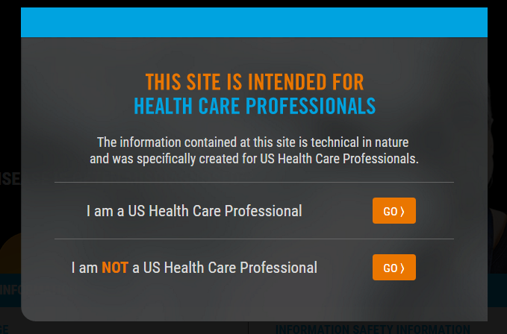

HCP Interstitial (JS error message)  
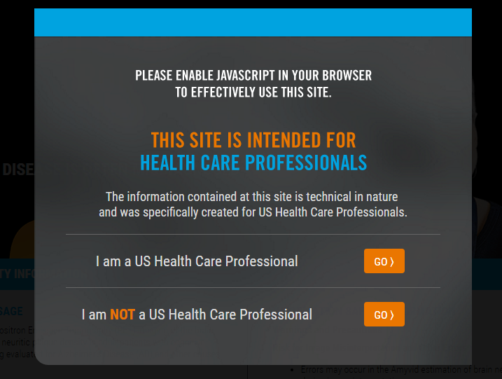

#### Navigation Actions

|  |  |  |  |
| --- | --- | --- | --- |
| **Area/Location** | **Action** | **Result** | **New or Same Tab/Window** |
| HCP Interstitial Modal | User selects “I am a US Health Care Professional” option | HCP Interstitial disappears so that user has access to [Home Page](#_Feature:_Home_Page) content | Same |
| HCP Interstitial Modal | User selects “I am NOT a US Health Care Professional” option | User is redirected to <https://www.lilly.com/home.aspx> | Same |
| HCP Interstitial Modal | User has arrived to the site through a training-specific redirect link (eg, certificate e-mail)and selects “I am a US Health Care Professional” option | HCP Interstitial disappears and Sign In Modal is presented. | Same |
| HCP Interstitial Modal (error message) | User has JavaScript disabled on their browser | Will display note on interstitial that reads “Please enable JavaScript in your browser to effectively use this site.” | Same |

### Feature: ISI Container Display

#### Business Rules

* ISI must be displayed on every page of the site above the user’s viewport (ie, the fold)—**the only exception being the Module Player pages**
* When the page loads, the ISI Display Container should be partially open enough to show “peek view” of content without user having to scroll on the Homepage only
* As soon as the user begins interacting with the page, the container will collapse into just an ISI header strip, attaching to the bottom of the viewport with the ISI header label on it on the Homepage only
  + Once collapsed, the ISI header strip continues to sit at the bottom of the page content until the user scrolls down to the point where the Static ISI on the page aligns with the same content as that within the ISI Display Container
  + At the point where the Static ISI on the page aligns with the same content in the container, the ISI Display Container stops being an overlay and seamlessly snaps to the rest of the page and scrolls with it
  + For all other site pages except Homepage and Module Player pages, ISI should appear in collapsed state when page loads
* At any point, users may choose to read the content within the ISI Display Container by clicking “Read More” on the ISI header strip and scrolling within the expanded container
  + If user clicks to expand the container manually via “Read More”, the ISI Display Container content should expand up to the top of the page content, but below the page Navigation Header
  + User can then also collapse the container manually via “Collapse” click – which will condense the ISI down to an ISI strip attached to the bottom of the viewport

#### Screen Mockup

ISI Container “Peek” View on Page Load  
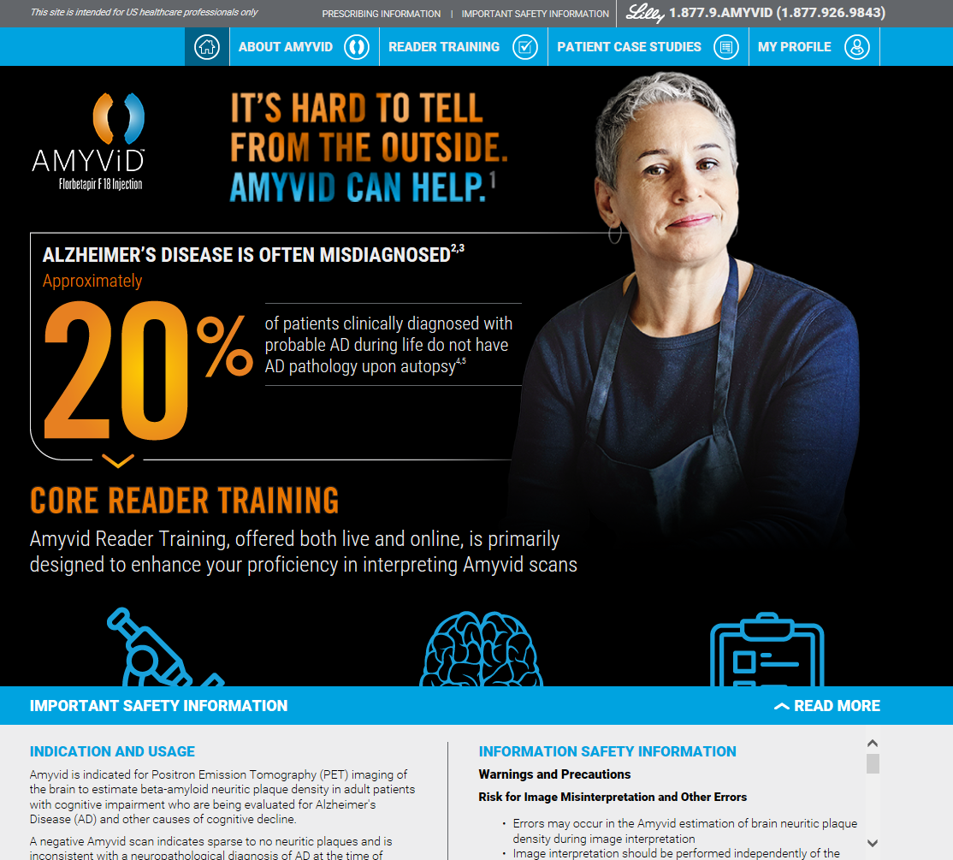

ISI Collapse Once User Interacts With Page  
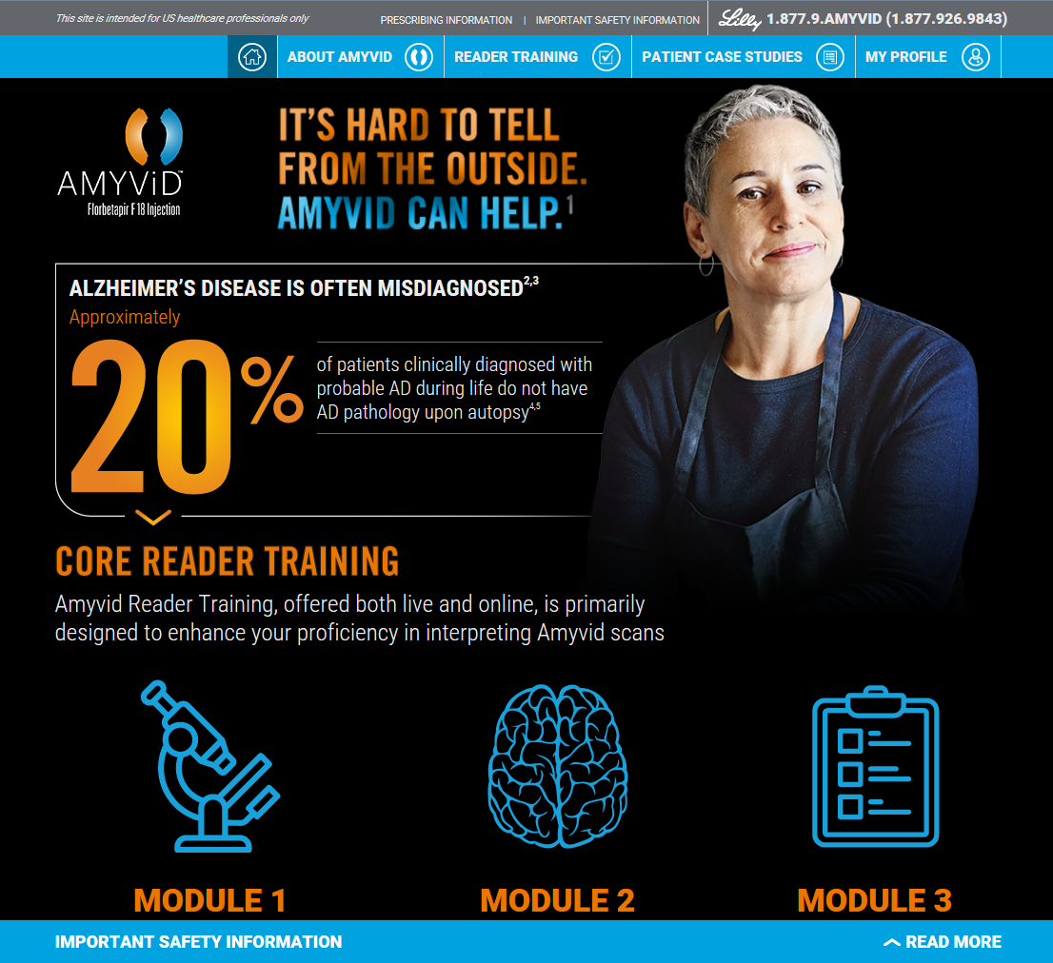

ISI Expand View if User Manually Clicks “Read More”  
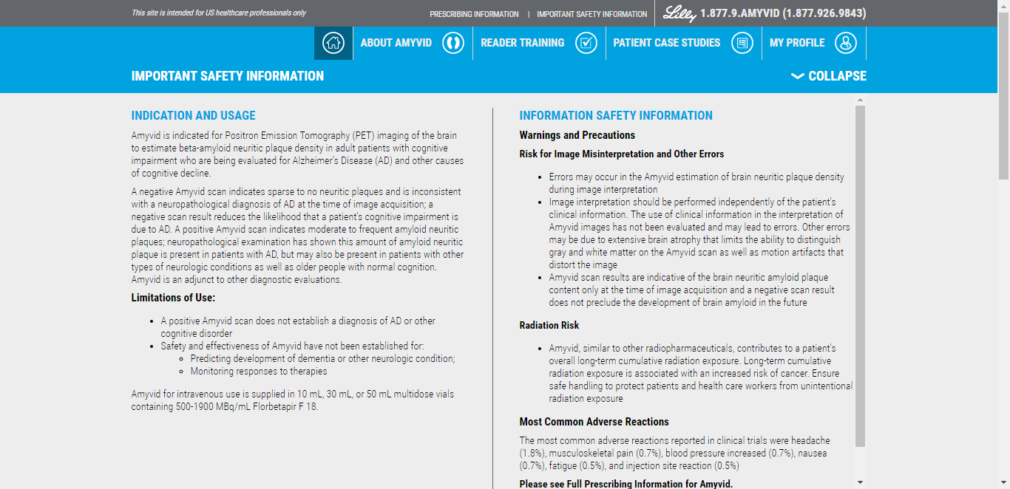

Static ISI on Bottom of Pages   
(once ISI Display Container content aligns with static content and disappears)

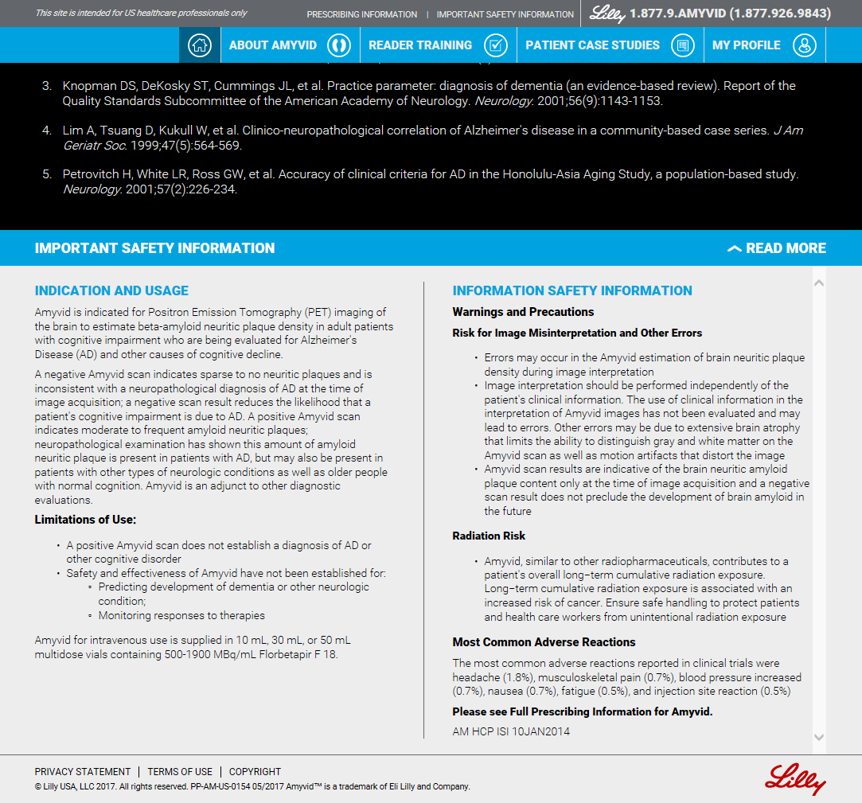

#### Navigation Actions

|  |  |  |  |
| --- | --- | --- | --- |
| **Area/Location** | **Action** | **Result** | **New or Same Tab/Window** |
| ISI Display Container | User interacts with homepageafter it first loads | ISI Display Container condenses into an ISI header strip attached to bottom of viewport with “Read More” link available | N/A |
| ISI Display Container | User clicks “Read More” link on ISI Display Container header strip | ISI Display Container content expands up to the top of page content, but below the Top Site Header; The “Read More” link changes to become “Collapse” link | N/A |
| ISI Display Container/Static ISI at bottom of page | User scrolls down page to the point where Static ISI content on the page aligns with the same content in the ISI Display Container | ISI Display Container stops being an overlay and seamlessly snaps to the rest of the page and scrolls with it | N/A |
| Static ISI at bottom of page | User clicks Please see Full Prescribing Information for Amyvid hyperlink at bottom of Static ISI | A new tab/window opens, presenting user with PDF of PI information [<http://pi.lilly.com/us/amyvid-uspi.pdf>] | New |

### Feature: LockedTop Site Header

#### Business Rules

* This header will appear on every page of the site (including above Module Player page)
* **Content**
  + Intended audience text:
    - *This site is intended for US Health Care Professionals only.*
  + Hyperlinks:
    - *Important Safety Information*
    - *Prescribing Information*
  + Ask Lilly info:
    - White Lilly logo image (asset file: *lilly_logo_white.png*)
    - *1.877.9.AMYVID (1.877.926.9843)*

#### Screen Mockup

Top Site Header

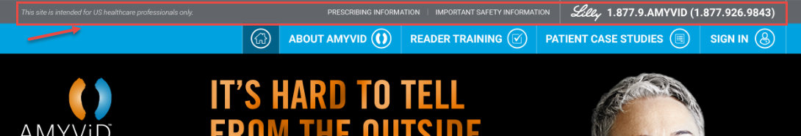

#### Navigation Actions

|  |  |  |  |
| --- | --- | --- | --- |
| **Area/Location** | **Action** | **Result** | **New or Same Tab/Window** |
| Top Site Header | User clicks “Important Safety Information” link | ISI Display Container expands to fill the user’s viewport up to the bottom of the navigation header | Same |
| Top Site Header (all pages) | User clicks “Prescribing Information” | A new tab/window opens, presenting user with PDF of PI information [<http://pi.lilly.com/us/amyvid-uspi.pdf>] | New |

### Feature: Site Footers

#### Business Rules

* This footer will appear on every page of the site (including Module Player page)
* **Content**:
  + Hyperlinks:
    - *Privacy Statement*
    - *Terms of Use*
    - *Copyright*
  + Intended audience text:
    - *©Lilly USA, LLC 2017. All rights reserved. PP-AM-US-0154 05/2017 Amyvid™ is a trademark of Eli Lilly and Company.*
  + Lilly logo:
    - On Maintenance Page and Error Page = white Lilly logo image (*lilly_white.77.png*)
    - On all other pages = red Lilly logo image (*lilly_red.png*)

#### Screen Mockup

Site Footer on Maintenance/Error Pages  


Site Footer on All Other Pages  


#### Navigation Actions

|  |  |  |  |
| --- | --- | --- | --- |
| **Area/Location** | **Action** | **Result** | **New or Same Tab/Window** |
| Left justified area of footer, first line | User clicks “Privacy Statement” link | A new tab/window opens link [<https://www.lillyhub.com/legal/lillyusa/english/privacy.html>] | New |
| Left justified area of footer, first line | User clicks “Terms of Use” link | A new tab/window opens link [<https://www.lillyhub.com/legal/lillyusa/english/termsofuse.html>] | New |
| Left justified area of footer, first line | User clicks “Copyright” link | A new tab/window opens link [<https://www.lillyhub.com/legal/lillyusa/english/copyright.html>] | New |
| Right justified area of footer | User clicks Lilly logo | Opens link [<https://www.lilly.com/home.aspx>] | New |

### Feature: Navigation Header for Main Pages

#### Business Rules

* NavigationHeader will remain locked at the top while the user scrolls/navigates down through page content
* Navigation Header will include hyperlinked buttons to main Content Areas of the site, which include:
  + Home button
    - No text, icon only (*nav.home.png*)
    - Button should be in “depressed” state while on Home Page
  + About Amyvid button
    - Text = “About Amyvid” with icon (*nav.about.png*)
    - Button should be in “depressed” state while on About Amyvid Page
  + Reader Training button
    - Text = “Reader Training” with icon (*nav.reader.png*)
    - Button should be in “depressed” state while on Reader Training Page
  + Patient Case Studies
    - Text = “Patient Case Studies” with icon (*nav.studies.png*)
    - Button should be in “depressed” state while on Patient Case Studies Page
  + My Profile button
    - Text = “My Profile” with icon (*nav.profile.png*)
    - Button should be in “depressed” state while on following pages:
      * My Profile Page
      * My Profile: Change Information Page
      * My Profile: Change Password Page

#### Screen Mockup

Navigation Header for Main Pages  


Navigation Header – Example “Depressed” Button State  


#### Navigation Actions

|  |  |  |  |
| --- | --- | --- | --- |
| **Area/Location** | **Action** | **Result** | **New or Same Tab/Window** |
| Navigation Header | User clicks Home header button | User is redirected to [Home Page](#_Feature:_Home_Page) | Same |
| Navigation Header | User clicks “About Amyvid” header button | User is redirected to About Amyvid Page | Same |
| Navigation Header | User clicks “Reader Training” header button | User is already signed into their account: Redirected to Reader Training Page  User is not yet signed into account:  Sign-In Modal pops up | Same |
| Navigation Header | User clicks “Patient Case Studies” header button | User is redirected to Patient Case Studies Page | Same |
| Navigation Header | User clicks “My Profile” header button | User is already signed into their account: Redirected to My Profile Page  User is not yet signed into account:  Sign-In Modalpops up over page the user is on before redirecting | Same |

### Feature: Maintenance Outage Page

#### Business Rules

* User is redirected from any site URL to the Site Maintenance Page when there is planned maintenance/down-time on the site
* Top Site Header or Page Navigation Header are not visible at top of screen

#### Screen Mockup

Maintenance Page  
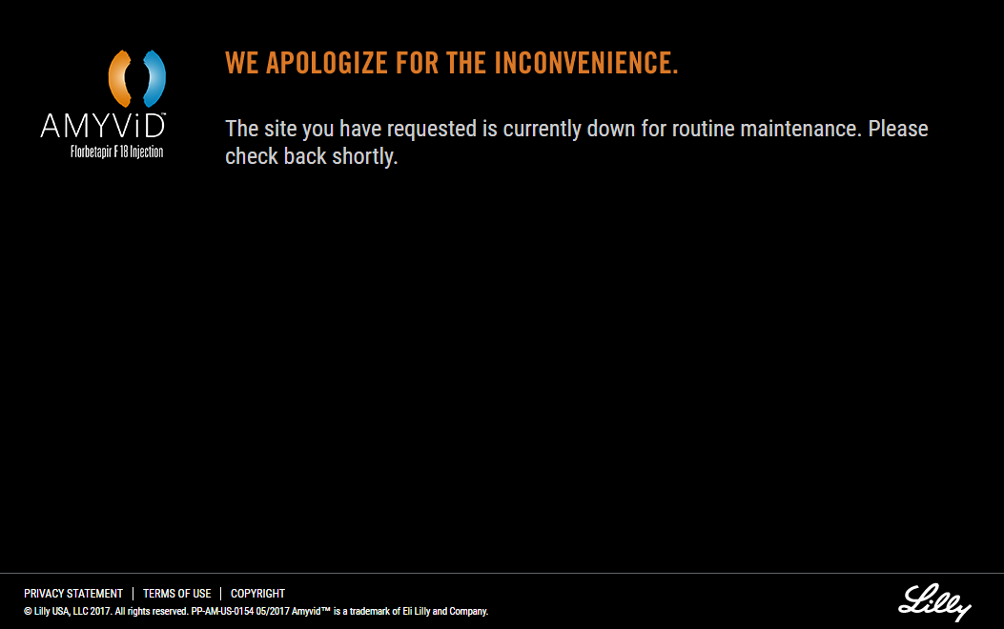

#### Navigation Actions

|  |  |  |  |
| --- | --- | --- | --- |
| **Area/Location** | **Action** | **Result** | **New or Same Tab/Window** |
| Amyvid logo | User clicks Amyvid logo | Nothing – logo is not clickable on this page | N/A |

### Feature: Error Page

#### Business Rules

* User is redirected to error page when any page errors occur on the site (eg, 404 screens)
* Top Site Header or Page Navigation Header are not visible at top of screen

#### Screen Mockup

Error Page  
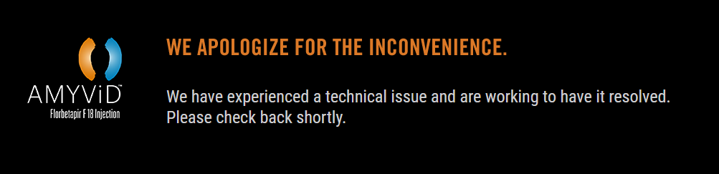

#### Navigation Actions

|  |  |  |  |
| --- | --- | --- | --- |
| **Area/Location** | **Action** | **Result** | **New or Same Tab/Window** |
| Amyvid logo | User clicks Amyvid logo | Nothing – logo is not clickable on this page | N/A |

## Main Site Pages

### Feature: Home Page

#### Business Rules

* User is navigated to Home Page (after clicking through HCP Interstitial Modal) if navigating to any of the following URLs: amyvidhcp.com, amyvid.com, or amyvidtraining.com
* Page Navigation Header is visible at top of screen, with “Home” button depressed/inactive

#### Screen Mockup

Home Page  
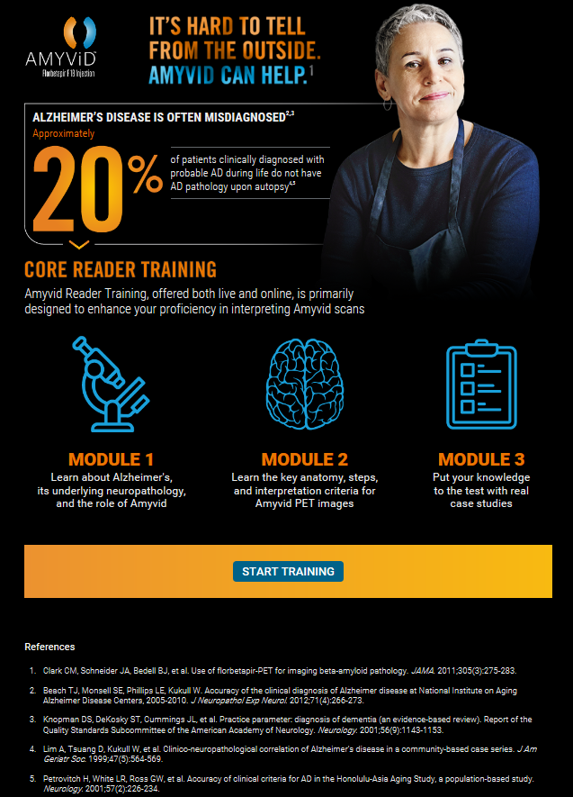

#### Navigation Actions

|  |  |  |  |
| --- | --- | --- | --- |
| **Area/Location** | **Action** | **Result** | **New or Same Tab/Window** |
| Amyvid Logo | User clicks Amyvid Logo image | User is redirected to [Home Page](#_Feature:_Home_Page) | Same |
| Home Page > References | User clicks any numeric, superscripted reference number | User is “jump” linked down to anchor at the top of “References” content | Same, anchored link |
| Home Page > Arrow navigation image | User clicks “down” arrow image below “20%” image | User is “jump” linked down to anchor at the top of “Core Reader Training” header/content | Same, anchored link |
| Home Page > Training content area | User clicks “START TRAINING” button or anywhere on orange Call to Action bar | User is already signed into their account: Redirected to Reader Training Page  User is not yet signed into account:  Sign-In Modalpops up | Same |

### Feature: About Amyvid Page

#### Business Rules

* User is navigated to About Amyvid page by clicking the Navigation Header link to the page
* Page Navigation Header is visible at top of screen, with “About Amyvid” button depressed/inactive

#### Screen Mockup

About Amyvid Page (1 of 2)  
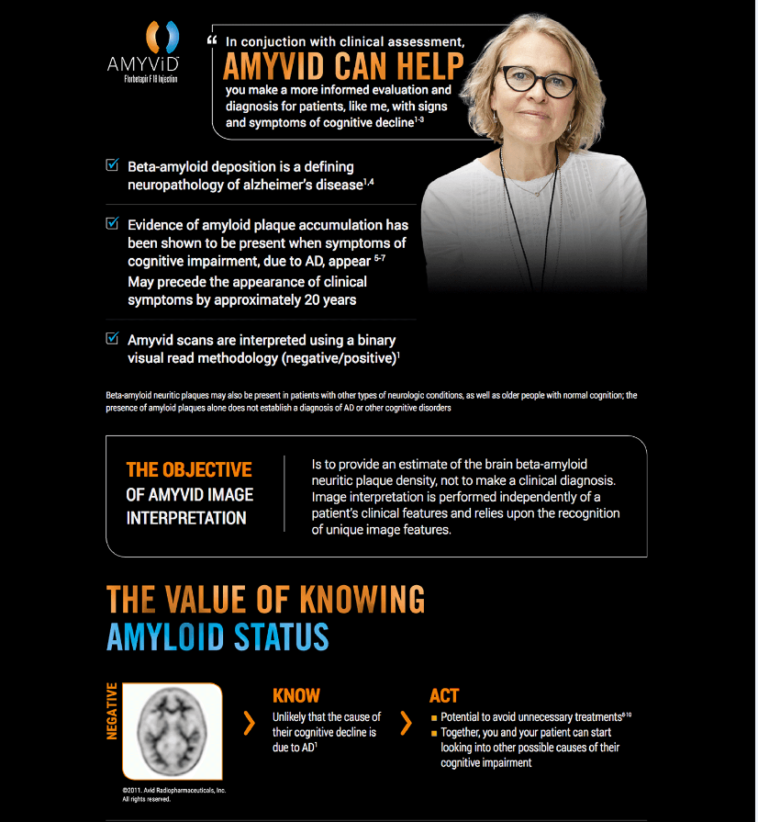

About Amyvid Page (2 of 2)  
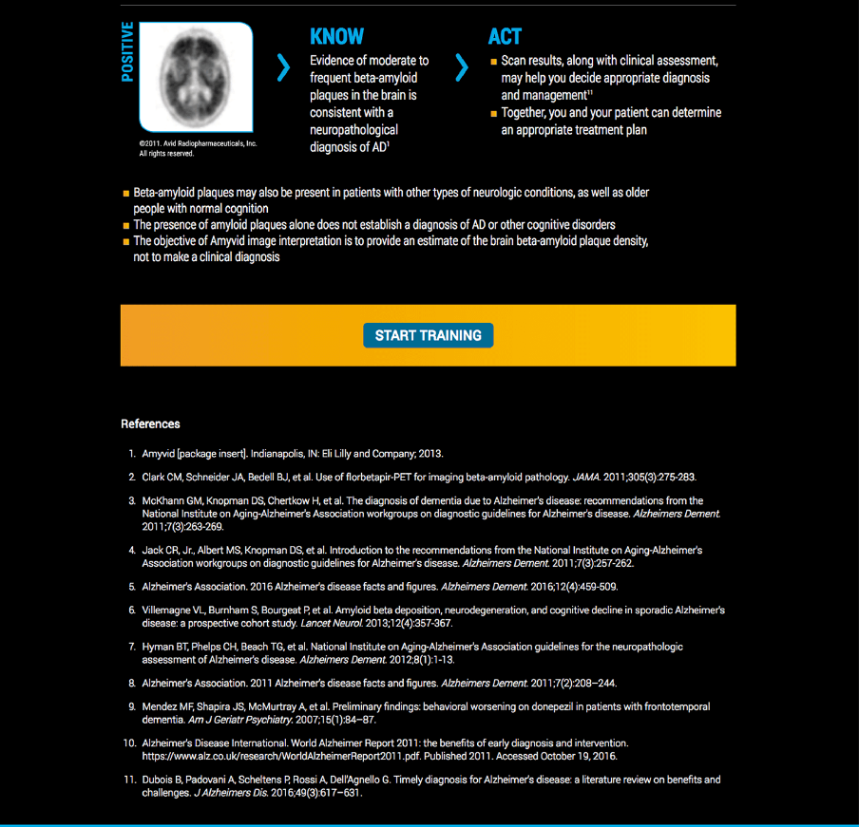

#### Navigation Actions

|  |  |  |  |
| --- | --- | --- | --- |
| **Area/Location** | **Action** | **Result** | **New or Same Tab/Window** |
| Amyvid Logo | User clicks Amyvid Logo image | User is redirected to [Home Page](#_Feature:_Home_Page) | Same |
| About Amyvid> References | User clicks any numeric, superscripted reference number | User is “jump” linked down to anchor at the top of “References” content | Same, anchored link |
| About Amyvid >Call to Action bar | User clicks “START TRAINING” button or anywhere on orange Call to Action bar | User is already signed into their account: Redirected to [Reader Training Page](#_Feature:_Reader_Training)  User is not yet signed into account:  Sign-In Modal pops up | Same |

### Feature: Patient Case Studies Page

#### Business Rules

* User is navigated to Patient Case Studies page by clicking the Navigation Header link to the page
* Page Navigation Header is visible at top of screen, with “Patient Case Studies” button depressed/inactive
* Each of the patient case images in the top-right corner of the page should be anchor linked to the section of the page with that particular patient’s case information
* Each patient case has three categories of content that can be selected to change content view
* Within the “Imaging Report” content, where there is an image of the report displayed—user should be able to click to see a pop-up/zoomed in view of the image

#### Screen Mockup

Patient Case Studies Page – Default View  
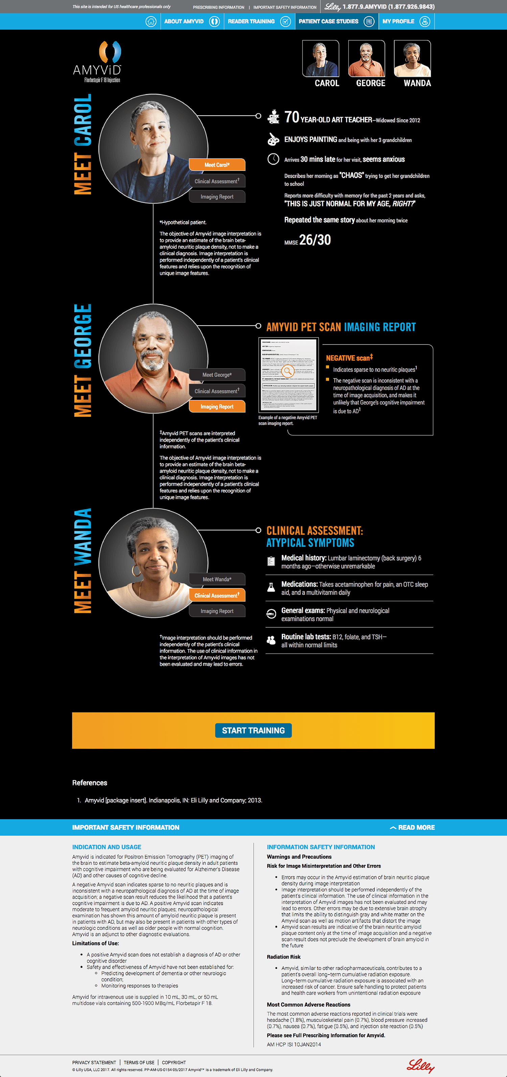

“Meet ____” Content  
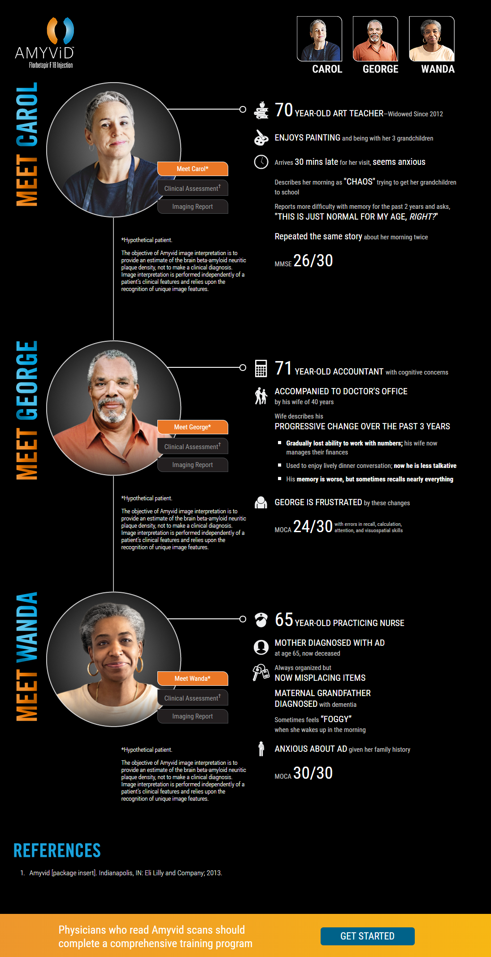

“Clinical Assessment” Content  
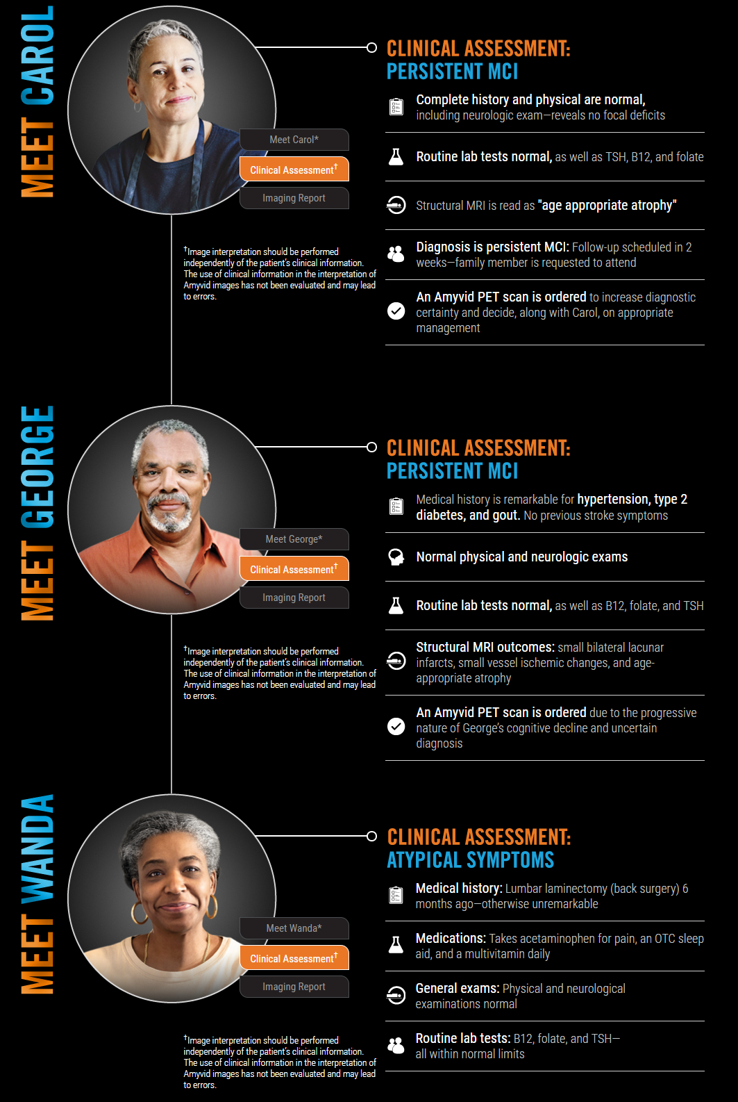

“Imaging Report” Content  
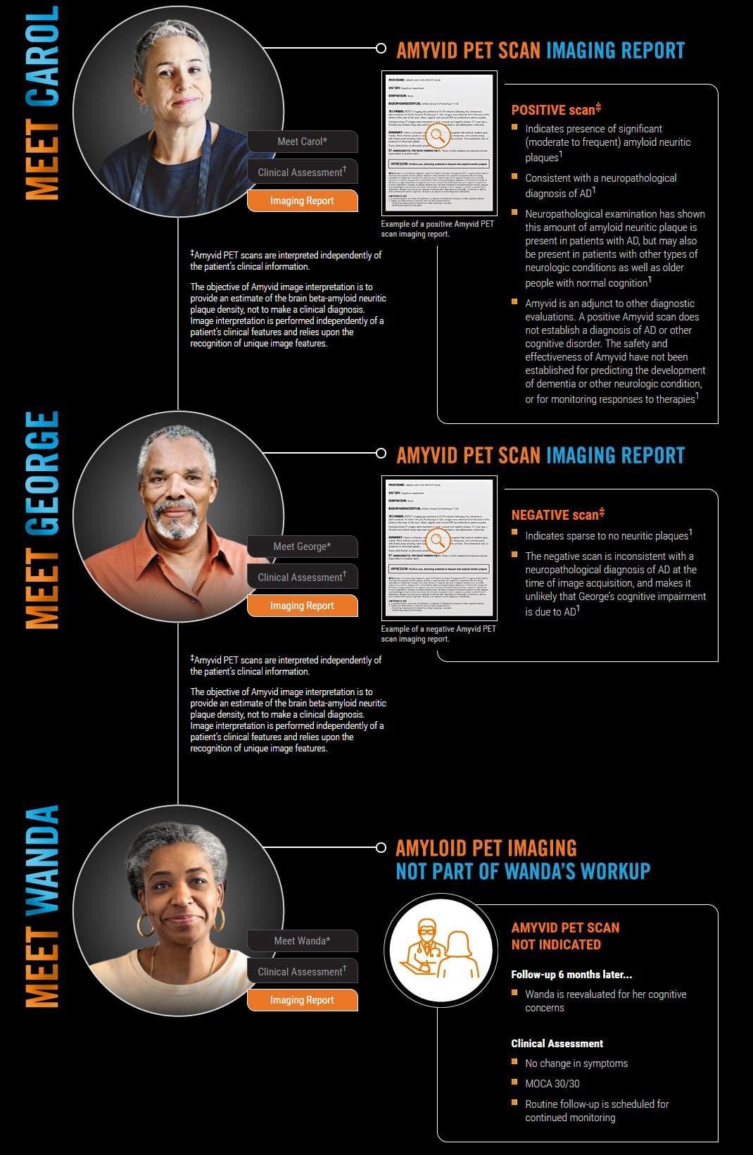

“Imaging Report” Content (Zoomed Image View)  
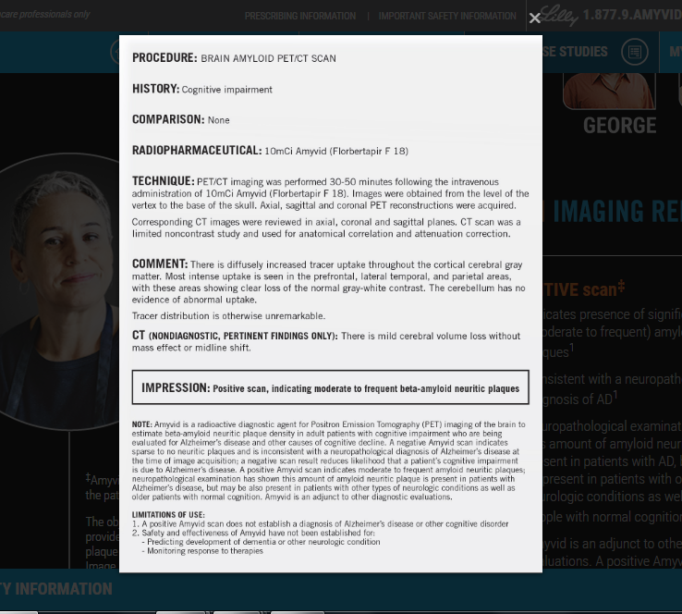

#### Navigation Actions

|  |  |  |  |
| --- | --- | --- | --- |
| **Area/Location** | **Action** | **Result** | **New or Same Tab/Window** |
| Amyvid Logo | User clicks Amyvid Logo image | User is redirected to [Home Page](#_Feature:_Home_Page) | Same |
| Patient Case Images | User clicks an image of patient in top-right of page | User is “jump” linked down to anchor at top of section for the person | Same, anchored link |
| Section buttons | User clicks “Meet ___”, “Clinical Assessment”, or “Imaging Report” content buttons next to patient | Content on page changes to display the appropriate content for button clicked | Same |
| Patient Case Studies> References | User clicks any numeric, superscripted reference number | User is “jump” linked down to anchor at the top of “References” content | Same, anchored link |
| Patient Case Studies > Call to Action bar | User clicks “START TRAINING” button or anywhere on orange Call to Action bar | User is already signed into their account: Redirected to [Reader Training Page](#_Feature:_Reader_Training)  User is not yet signed into account:  Sign-In Modal pops up | Same |

### Feature: Reader Training Page

#### Business Rules

* User is navigated to Reader Training Page after successfully signing in via the Sign-In Modal or after registering via the [Registration Thank You Page](#_Feature:_Registration_Thank)
* User’s progress should be displayed under modules they have started
* All Core Reader Training modules (Modules 1-3) must be completed in sequential order
* Additional Reader Training Resources are inactive/not available until user has completed all Core Reader Training Modules (Modules 1-3)
* 4 Module listing “button states”
  + Start (orange background) – displays if user has not completed module, but has completed pre-requisite (class="*btn pgch none view*")
  + Resume (orange background) – displays if user has started a module, but has not completed it (class="*btn pgch view*")
  + Revisit (gray background) – displays if user has completed a module (class=”*btn pgch revisit*”)
  + Pre-requisite not met message – displays if user has not completed a module’s pre-requisite (class=”*seventeen*”)
* Display rules for button states described below per Module area and per user pre-requisite activity:
  + Module 1
    - If Module 1 not yet started = “Start” button
    - If Module 1 started, but not completed = “Resume” button
    - If Module 1 completed = “Revisit” button
  + Module 2
    - If Module 1 not complete = No button - “*Please complete Module 1 for access*” pre-requisite message
    - If Module 1 complete, but Module 2 not yet started = “Start” button
    - If Module 2 started, but not completed = “Resume” button
    - If Module 2 completed = “Revisit” button
  + Module 3
    - If Module 2 not complete = No button - “*Please complete Modules 1 and 2 for access*” pre-requisite message
    - If Module 2 complete, but Module 3 not yet started = “Start” button
    - If Module 3 started, but not completed = “Resume” button
    - If Module 3 completed = “Revisit” button
  + Additional Scans for Review (Module 5)
    - If Module 3 not complete = No button - “*Please complete Modules 1-3 for access*” pre-requisite message
    - If Module 3 complete, but Additional Scans (Module 5) not yet started = “Start” button
    - If Additional Scans (Module 5) started, but not completed = “Resume” button
    - If Additional Scans (Module 5) completed = “Revisit” button
* Once user has completed Modules 1-3, a blue display bar will be shown on this page that will include:
  + A “View Certificate” button to click in order to view/print certificate
  + A “Rate Training” button will display if user has not yet completed the post-Core Reader Training survey (which is also displayed to user to optionally complete after finishing module 3), to allow user tore-prompt the survey page in order to complete the survey at their own convenience (see Core Training Complete/Survey Pagesection for more detail on this page’s specific requirements),
  + ~~If user has already taken the survey for modules 1 through 3, the “Rate Training” button will not show~~

#### Screen Mockup

Reader Training Page – All Button States  
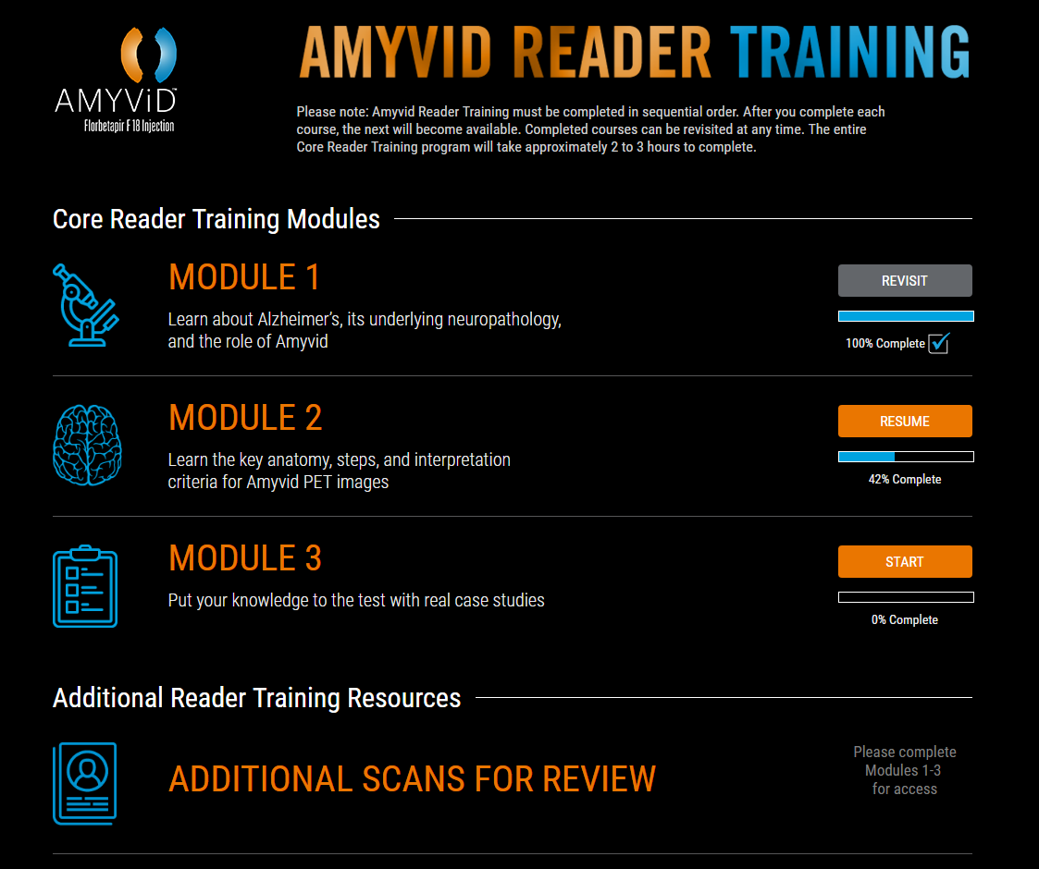

Reader Training Page – Core Training Complete Display Bar (Survey Incomplete)  
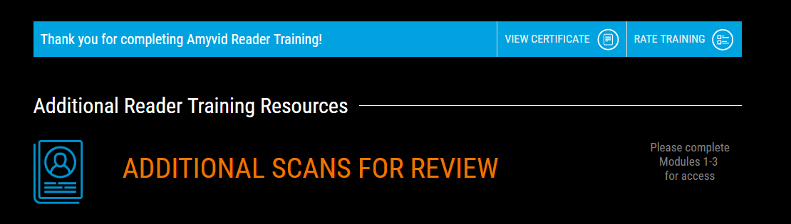

#### Navigation Actions

|  |  |  |  |
| --- | --- | --- | --- |
| **Area/Location** | **Action** | **Result** | **New or Same Tab/Window** |
| Amyvid Logo | User clicks Amyvid Logo image | User is redirected to [Home Page](#_Feature:_Home_Page) | Same |
| Reader Training Page | User clicks “Start” button next to module | User is presented with Module Player window and first welcome slide of module content | Same |
| Reader Training Page | User clicks “Resume” button next to module | User is presented with Module Player window and Module Player – Resume message to ask if they’d like to resume where they left off or restart the module content | Same |
| Reader Training Page | User clicks “Revisit” button next to module | User is presented with Module Player window and Module Player – Resume message to ask if they’d like to resume where they left off or restart the module content | Same |
| Reader Training Page > Modules 1-3 complete | User clicks “View Certificate” button on completion bar | View/Print Certificate Modal is displayed (page behind is dimmed/inactive) | Same (modal) |
| Reader Training Page > Modules 1-3 complete | User clicks “Rate Training” button on completion bar | User is redirected to Core Training Survey Page – Reprompted version of the survey | Same |

## User Account-Based Pages

### Feature: FIA Load Process and User Account Management

#### Business Rules

Please see Hibbert’s Program Acknowledgement document for full FIA process requirements

### Feature: Sign In Modal

##### Business Rules

* Sign-In Modal is prompted if user attempts to access the [Reader Training Page](#_Feature:_Reader_Training) in any way and is not logged in (eg, Navigation Header “My Profile” button and“Get Started” hyperlinks on Home, About Amyvid, and Patient Case Studies pages)
* The modal should stay on page and not allow user to move forward until user either submits a valid sign-in, chooses to register a new account or closes the modal window (this modal should allow user to have the option to close the modal via an “X” in top-right corner)
* The page behind the Sign-In modal should be dimmed/inactivated so that user can’t interact with it
* User must enter valid E-mail Address and Password to Sign In
* When user clicks “Sign In” button, site should first validate/authenticate Email Address field (throwing any relevant errors), and then authenticate Password field
* User can optionally choose to “Register Now” if they do not have an account
* Include “Remember Me” functionality for username only

##### Screen Mockup

Sign In Modal  
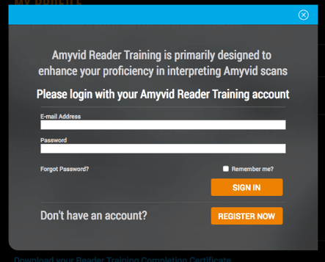

Sign In Modal – In-Line Errors (Required Fields)  
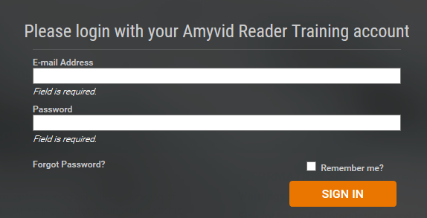

Sign In Modal – In-Line Errors (Invalid E-mail Format)  
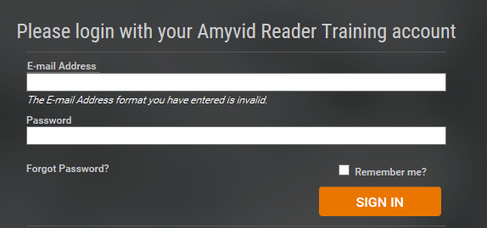

Sign In Modal – Post-“Sign In” Click Errors (Can’t Find Account)  
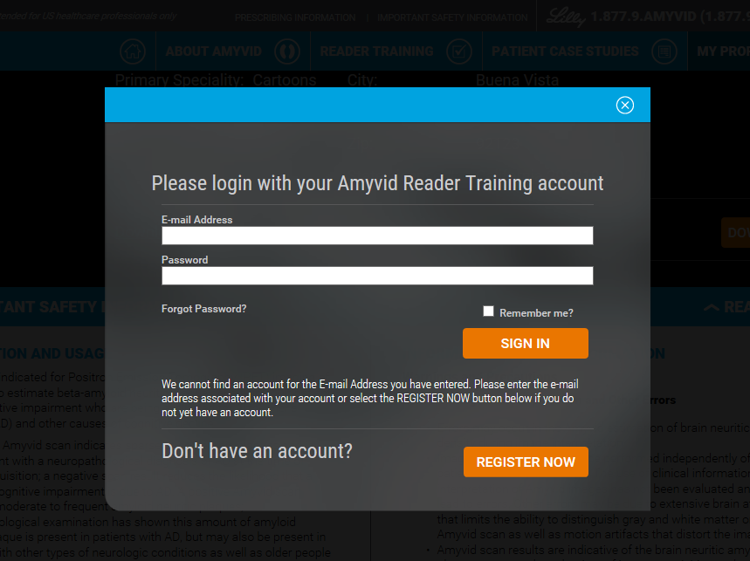

Sign In Modal – Post-“Sign In” Click Errors (Incorrect Password)  
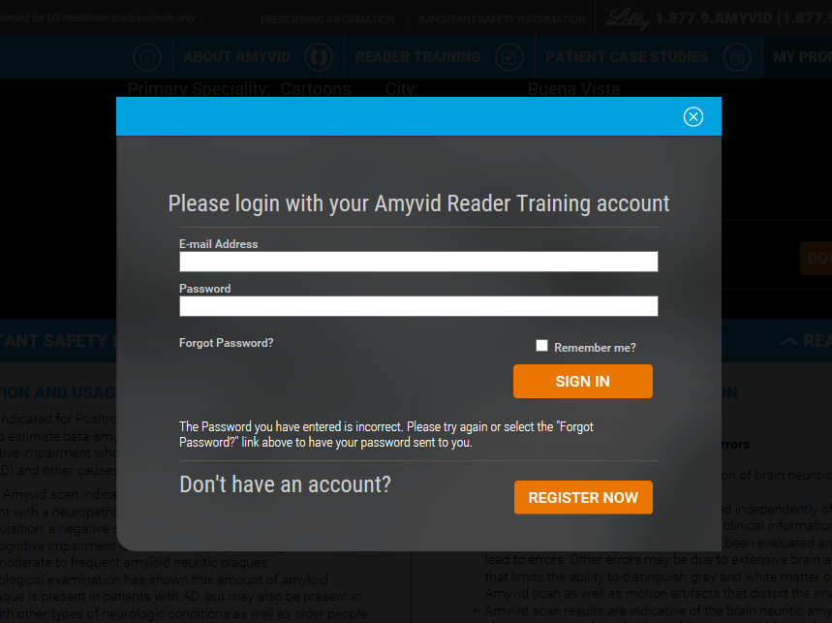

##### Navigation Actions

|  |  |  |  |
| --- | --- | --- | --- |
| **Area/Location** | **Action** | **Result** | **New or Same Tab/Window** |
| Sign-In Modal | User enters valid E-mail Address and Password, clicks “Sign In” button | Sign-In Modal closes and page refreshes to display Reader Training Page | Same |
| Sign-In Modal (error message) | User leaves any required field blank | “*Field is Required*” error messages display | Same |
| Sign-In Modal (error message) | User enters an invalid E-mail Address (not in [xxx@xyz.com](mailto:xxx@xyz.com) format) OR leaves E-mail Address blank, and clicks “Sign In” button | Error Message displays beneath “Sign In” button that reads: *“The E-mail Address format you have entered is invalid.”* | Same |
| Sign-In Modal (error message) | User enters an E-mail Address that does not match current HCP database, and clicks “Sign In” button | Error Message displays beneath “Sign In” button that reads: *“We cannot find an account for the E-mail Address you have entered. Please enter the e-mail address associated with your account or select the REGISTER NOW button below if you do not yet have an account.”* | Same |
| Sign-In Modal (error message) | User enters an invalid Password or leaves Password blank, and clicks “Sign In” button | Error Message displays beneath “Sign In” button that reads: *“The Password you have entered is incorrect. Please try again or select the ‘Forgot Password?’ link above to have your password sent to you.”* | Same |
| Sign-In Modal | User checks the “Remember me? checkbox and then selects “Sign In” button (“check” should persist even if errors above are thrown) | User’s Email Address field is stored in their cookies so that it displays in future sessions where Sign-In Modal is prompted for the user | Same |
| Sign-In Modal | User clicks “Forgot Password?” hyperlink | Sign-In Modal closes and Forgot Password Request Page is displayed | Same |
| Sign-In Modal | User clicks “Register Now” button | Sign-In Modal closes and Registration Page is displayed | Same |
| Sign-In Modal | User clicks “X” in top-right corner of modal | Modal window closes | Same |

### Feature: Alternate User Flow for Access via LRT E-mail Links

##### Business Rules

* Users that access the site via the link contained in the LRT E-mails with temporary login credentials will be taken through the following flow:
  + User clicks link contained within LRT E-mail
  + User is taken to site and is immediately prompted with the HCP Interstitial
  + Upon successfully clicking through the HCP Interstitial, the user should be immediately presented with the Sign In modal
  + Upon successfully signing in, page should redirect user to My Profile – Change Password
  + Upon successfully updating their password, user will be taken to My Profile – Change Information to confirm their information and enter any required fields not previously received from the LRT load file
  + Upon successfully confirming their information, user is redirected to the Reader Training Page

### Feature: Forgot Password Request Page

#### Business Rules

* Forgot Password page will be prompted when user selects “Forgot Password?” on the Login modal
* Forgot Password page will be a modal/overlay on top of main site page
* Modal includes verbiage instructing user to enter their email address, a field for email address entry, Submit button
* Once user submits, a screen will display confirming password has been sent to email entered
* If user enters and email not associated with a current account, an error message will display

#### Screen Mockup

Forgot Password Request Page  
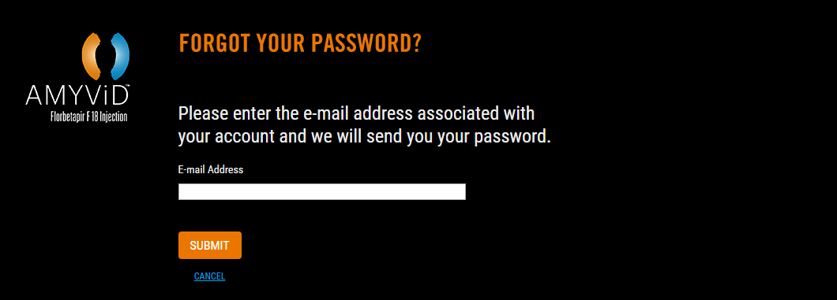

Forgot Password Request Page – Error (Invalid E-mail)  
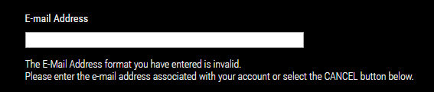

#### Navigation Actions

|  |  |  |  |
| --- | --- | --- | --- |
| **Area/Location** | **Action** | **Result** | **New or Same Tab/Window** |
| Amyvid Logo | User clicks Amyvid Logo image | User is redirected to Home Page | Same |
| Forgot Password Request Page | User enters a valid E-mail Address, and clicks “SUBMIT” button | Forgot Password E-mail is sent to user and user is redirected to Forgot Password Sent Page | Same |
| Forgot Password Request Page (error message) | User enters an invalid E-mail Address that does not match current HCP database and clicks “SUBMIT” button | Error Message displays beneath the E-mail Address field that reads: *“The E-mail Address format you have entered is invalid. Please enter the e-mail address associated with your account or select the CANCEL button below.”* | Same |
| Forgot Password Request Page | User clicks “CANCEL” button | Sign-In Modal appears in front of page (which becomes dimmed/inactive) | Same |

### Feature: Forgot Password Sent Page

#### Business Rules

* User is redirected to Forgot Password Sent Page if user successfully submits Forgot Password Request Page

#### Screen Mockup

Forgot PasswordSent Page  
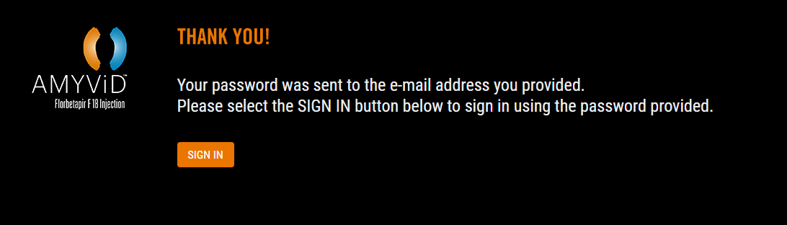

#### Navigation Actions

|  |  |  |  |
| --- | --- | --- | --- |
| **Area/Location** | **Action** | **Result** | **New or Same Tab/Window** |
| Amyvid Logo | User clicks Amyvid Logo image | User is redirected to Home Page | Same |
| Forgot Password Sent Page | User selects “Sign In” button | Sign-In Modal appears in front of page (which becomes dimmed/inactive) | Same |

### Feature: Registration Page

#### Business Rules

* User is redirected to Registration Page when choosing Register Now button on the Sign-In Modal
* Once user clicks submit, the profile is created and stored in the database.
* **Entry fields:**
  + First Name
    - Field type: open text
    - Validation:
      * Field is required
  + Last Name
    - Field type: open text
    - Validation:
      * Field is required
  + Address 1
    - Field type: open text
    - Validation:
      * Field is required
  + Address 2 (optional)
    - Field type: open text
    - Validation: none
  + City
    - Field type: open text
    - Validation:
      * Field is required
  + State
    - Field type: drop-down
    - Validation:
      * Field is required
  + Zip
    - Field type: open text (zip format)
    - Validation:
      * Field is required
      * Format must be numbers only
      * Value must be 5 digits
  + Primary Specialty
    - Field type: drop-down
    - Validation:
      * Field is required
      * Must only display available list of CCR-approved Amyvid specialty options
  + Primary State Licensed In (optional)
    - Field type: drop-down
    - Validation: none
  + Primary State License Number (optional)
    - Field type: open text
    - Validation: none
  + E-mail Address
    - Field type: open text (email format)
    - Validation:
      * Field is required
      * Must be appropriate [xxx@xyz.com](mailto:xxx@xyz.com) format
      * Must validate if e-mail already exists in HCP account database
  + Confirm E-mail Address
    - Field type: open text (email format)
    - Validation:
      * Field is required
      * Must be appropriate [xxx@xyz.com](mailto:xxx@xyz.com) format
      * Must validate if e-mail already exists in HCP account database
      * Must validate that e-mail value is same value as entered within E-mail Address field
  + Password
    - Field type: open text
    - Validation:
      * Field is required
      * Value must be at least 8 characters long, with 1 numeric character
  + Confirm Password
    - Field type: open text
    - Validation:
      * Field is required
      * Value must be at least 8 characters long, with 1 numeric character
      * Must validate that value is same value as entered within Password field

#### Screen Mockup

Registration Page  
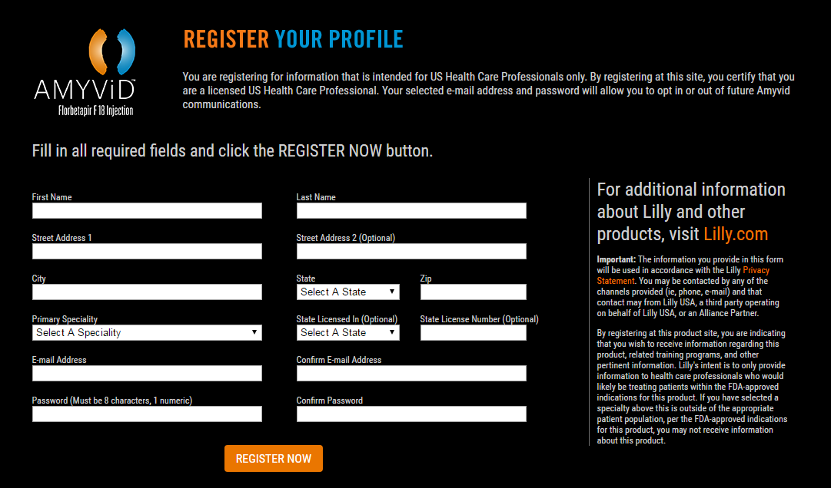

Registration Page – In-Line Errors (Required Fields)  
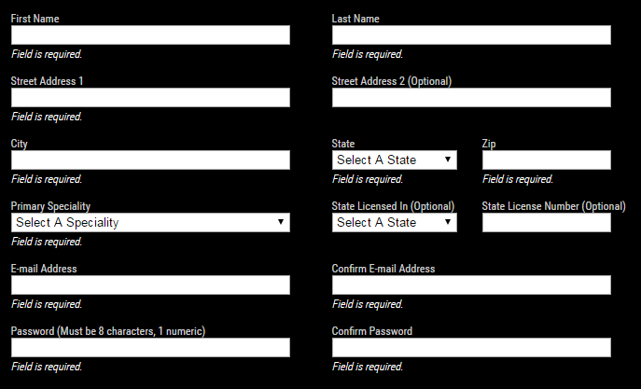

Registration Page – In-Line Errors (Invalid Formats)  
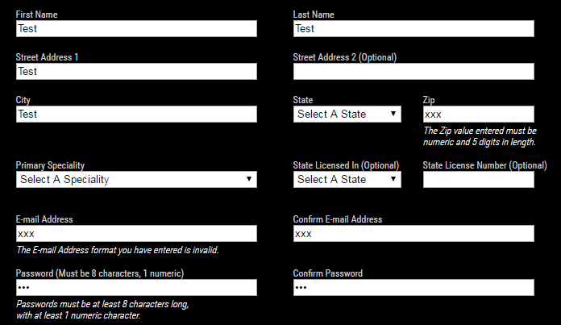

Registration Page – Post-“Register Now” Button Errors (Existing User)  
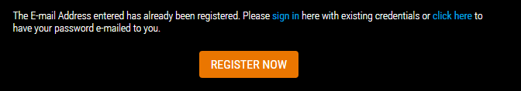

#### Navigation Actions

|  |  |  |  |
| --- | --- | --- | --- |
| **Area/Location** | **Action** | **Result** | **New or Same Tab/Window** |
| Registration Page | User fills out all fields appropriately and clicks “Register Now” button | User is redirected to Registration Thank You Page | Same |
| Registration Page  (error message) | User leaves any required field blank | Error message displays indicating required fields that are incorrectly blank: *“Field is required”* | Same |
| Registration Page  (error message) | User enters an invalid E-mail Address or Confirm E-mail Address field value (not in [xxx@xyz.com](mailto:xxx@xyz.com) format) | Error message displays that reads: *“The E-mail Address format you have entered is invalid.”* | Same |
| Registration Page  (error message) | User enters an invalid Password field value (not 8 characters, one numeric) | Error message displays that reads: *“Passwords must be at least 8 characters long, with at least 1 numeric character.”* |  |
| Registration Page  (error message) | User enters a value for “Confirm E-mail Address” field that does not match “E-mail Address” value entered | Error message displays that reads: “*E-mail Address and Confirm E-mail Address values must match”* | Same |
| Registration Page  (error message) | User enters a value for “Confirm Password” field that does not match “Password” value entered | Error message displays that reads: “*Password and Confirm Password values must match”* | Same |
| Registration Page  (error message) | User enters an E-mail Address value that already exists in the HCP account database and clicks “Submit” | Error message displays that reads: *“The E-mail Address entered has already been registered. Please sign in here with existing credentials or click here to have your password e-mailed to you.”* | Same |
| User selects “sign in” hyperlink from existing user error message above | Sign-In Modal appears in front of Registration Page (which becomes dimmed/inactive) | Same |
| User selects “click here” hyperlink from existing user error message above | User is redirected to Forgot Password Request Page | Same |
| Registration Page  (error message) | User enters an invalid Zip field value (not in numeric format or at least 5 digits) | Error message displays that reads: *“The Zip value entered must be numeric and 5 digits in length.”* | Same |
| Registration Page > Disclaimer area | User clicks “Lilly.com” hyperlink within text | Opens link [<https://www.lilly.com/home.aspx>] | New |
| Registration Page > Disclaimer area | User clicks “Privacy Statement” hyperlink within text | Opens link [<https://www.lillyhub.com/legal/lillyusa/english/privacy.html>] | New |

### Feature: Registration Thank You Page

#### Business Rules

* User is redirected to Registration Thank You Page when choosing Register Now button on the Registration Page

#### Screen Mockup

Registration Thank You Page  
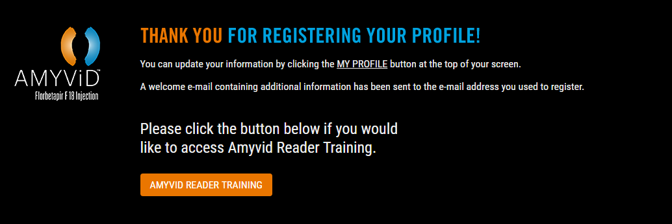

#### Navigation Actions

|  |  |  |  |
| --- | --- | --- | --- |
| **Area/Location** | **Action** | **Result** | **New or Same Tab/Window** |
| Amyvid Logo | User clicks Amyvid Logo image | User is redirected to [Home Page](#_Feature:_Home_Page) | Same |
| Registration Thank You Page | User clicks “My Profile” hyperlinked in Sub-header text | User is redirected to My Profile Page | Same |
| Registration Thank You Page | User clicks “Amyvid Reader Training” button | User is redirected to [Reader Training Page](#_Feature:_Reader_Training) | Same |

### Feature: My Profile Page

#### Business Rules

* This page should only be available to user after they have signed in
* User is navigated to My Profile Page after clicking My Profile button in any Page Navigation Header or other page hyperlink (if user is already logged in)
* User should only be presented with “Download your Reader Training Completion Certificate” option once Core Reader Training Modules (Modules 1-3) have been completed

#### Screen Mockup

My Profile Page  
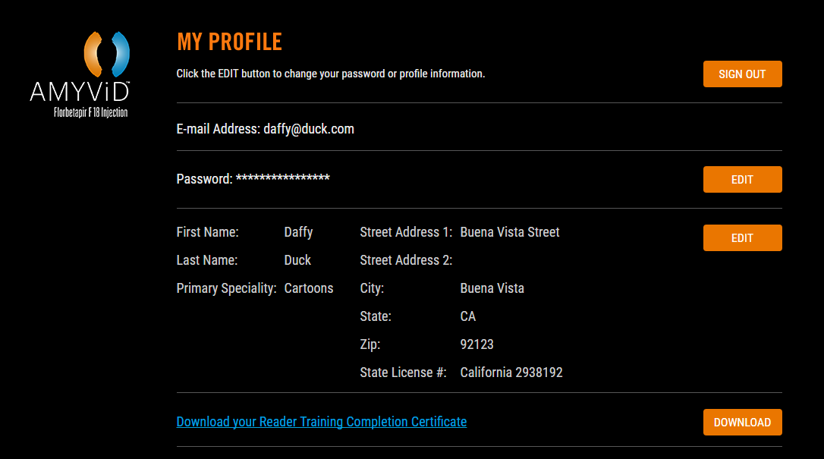

#### Navigation Actions

|  |  |  |  |
| --- | --- | --- | --- |
| **Area/Location** | **Action** | **Result** | **New or Same Tab/Window** |
| Amyvid Logo | User clicks Amyvid Logo image | User is redirected to [Home Page](#_Feature:_Home_Page) | Same |
| My Profile | User clicks “Sign Out” button | Sign Out Modal is displayed (page behind is dimmed/inactive) | Same |
| My Profile > Password section | User clicks “Edit” button | User is redirected to My Profile Page – Change Password | Same |
| My Profile > User info section | User clicks “Edit” button | User is redirected to My Profile Page – Change Information | Same |
| My Profile > Download certificate section | User clicks “Download” button | [View/Print Certificate Modal](#_Feature:_View/Print_Certificate)l is displayed (page behind is dimmed/inactive) | Same (modal) |

### Feature: Sign Out Modal

#### Business Rules

* This modal is displayed after clicking the “Sign Out” button on the My Profile Page
* The modal should stay on page and not allow user to move forward until user either selects “Yes” button, “Cancel” hyperlink, or closes the modal window (this modal should allow user to have the option to close the modal via an “X” in top-right corner)
* The page behind the modal should be dimmed/inactivated so that user can’t interact with it

#### Screen Mockup

Sign Out Modal  
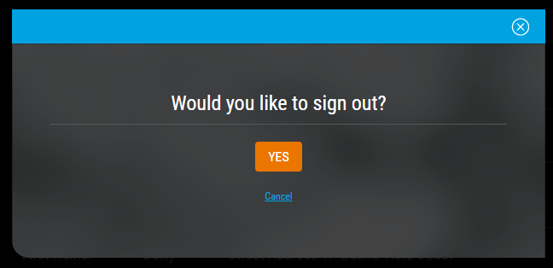

#### Navigation Actions

|  |  |  |  |
| --- | --- | --- | --- |
| **Area/Location** | **Action** | **Result** | **New or Same Tab/Window** |
| Sign Out Modal | User clicks “Yes” | User is signed out of their account and redirected to [Home Page](#_Feature:_Home_Page) | Same |
| Sign Out Modal | User clicks “Cancel” | Modal closes and user is still on My Profile Page | Same |
| Sign Out Modal | User clicks “X” in top-right corner of modal | Modal window closes | Same |

### Feature: View/Print Certificate Modal

#### Business Rules

* This modal is displayed after clicking to download the certificate – available in these locations:
  + Via the “Download” button on the My Profile Page
  + Via the “Download your Reader Training Completion Certificate” hyperlink on the My Profile Page
  + Via “View Certificate” button on the Reader Training Page (displayed once Mods 1-3 complete)
* The modal should stay on page and not allow user to move forward until user either selects “Yes” button, “Cancel” hyperlink, or closes the modal window (this modal should allow user to have the option to close the modal via an “X” in top-right corner)
* The page behind the modal should be dimmed/inactivated so that user can’t interact with it

#### Screen Mockup

View/Print Certificate Modal  
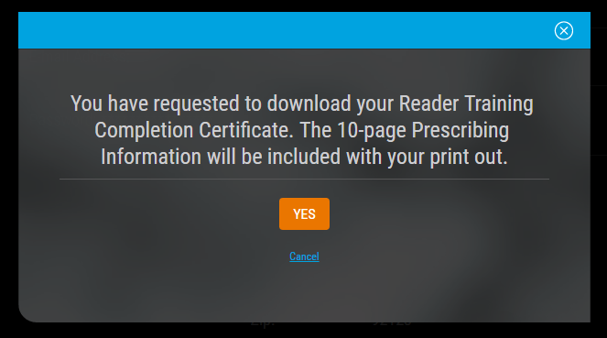

Example Certificate PDF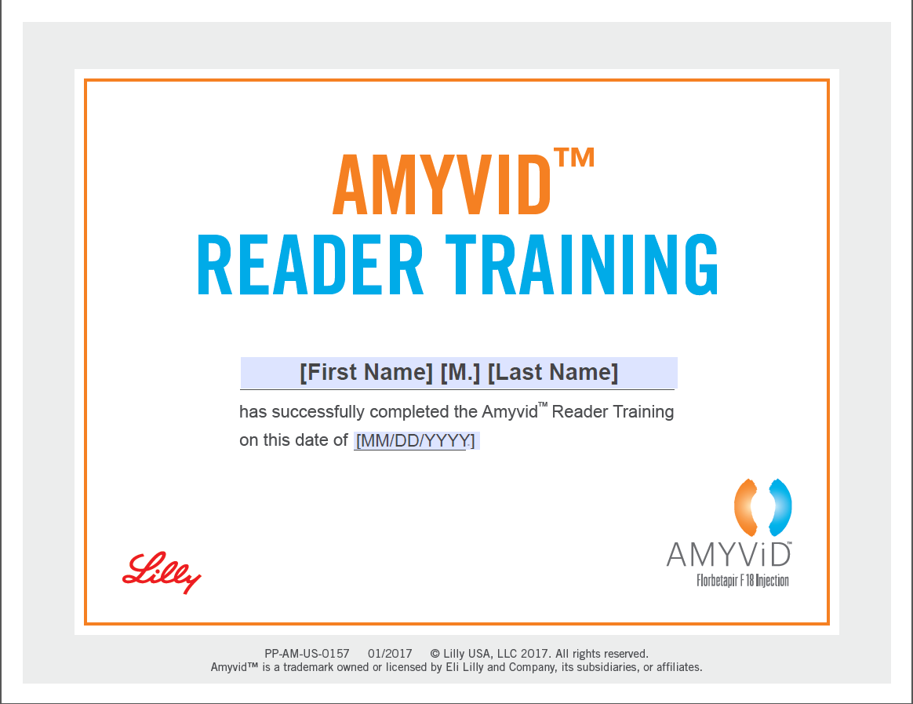

#### Navigation Actions

|  |  |  |  |
| --- | --- | --- | --- |
| **Area/Location** | **Action** | **Result** | **New or Same Tab/Window** |
| View/Print Certificate Modal | User clicks “Yes” | Certificate document PDF opens | New |
| View/Print Certificate Modal | User clicks “Cancel” | Modal closes and user is still on page they were on when modal was prompted | Same |
| View/Print Certificate Modal | User clicks “X” in top-right corner of modal | Modal window closes | Same |

### Feature: My Profile – Change Information Page

#### Business Rules

* User is navigated to My Profile – Change Information page after clicking “Edit” button next to user’s information on My Profile Page
* E-mail Address should be displayed, but not editable
* All fields should be pre-populated with current data in HCP database for user

#### Screen Mockup

My Profile Page – Change Information  
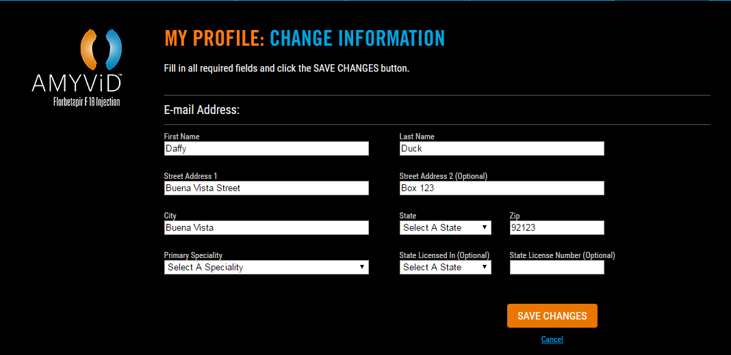

#### Navigation Actions

|  |  |  |  |
| --- | --- | --- | --- |
| **Area/Location** | **Action** | **Result** | **New or Same Tab/Window** |
| Amyvid Logo | User clicks Amyvid Logo image | User is redirected to [Home Page](#_Feature:_Home_Page) | Same |
| My Profile – Change Info Pg | User fills out all fields appropriately and clicks “Save Changes” button | Information is updated and user is presented with Profile Updated Modal | Same |
| My Profile – Change Info Pg (error message) | User leaves any required field blank | Error message displays indicating required fields that are incorrectly blank: *“Field is required”* | Same |
| My Profile – Change Info Pg (error message) | User enters an invalid Zip field value (not in numeric format or at least 5 digits) | Error message displays that reads: *“The Zip value entered must be numeric and 5 digits in length.”* | Same |
| My Profile – Change Info Pg | User clicks “Cancel” hyperlink | User is redirected back to [My Profile Page](#_Feature:_My_Profile) | Same |

### Feature: My Profile – Change Password Page

#### Business Rules

* User is navigated to My Profile – Change Password page after clicking “Edit” button next to user’s information on [My Profile Page](#_Feature:_My_Profile)
* E-mail Address should be displayed, but not editable
* Current password field should be pre-populated with current data in HCP database for user

#### Screen Mockup

My Profile Page – Change Password  
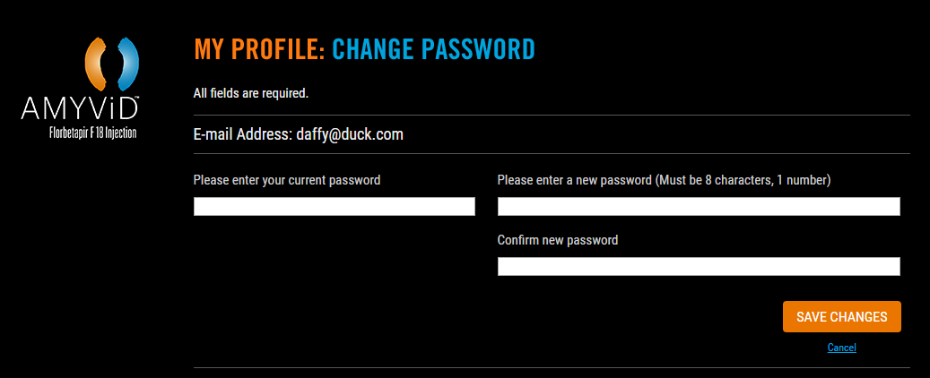

#### Navigation Actions

|  |  |  |  |
| --- | --- | --- | --- |
| **Area/Location** | **Action** | **Result** | **New or Same Tab/Window** |
| Amyvid Logo | User clicks Amyvid Logo image | User is redirected to [Home Page](#_Feature:_Home_Page) | Same |
| My Profile – Change Password Pg | User fills out all fields appropriately and clicks “Save Changes” button | Information is updated and user is presented withProfile Updated Modal | Same |
| My Profile – Change Password Pg (error message) | User leaves any required field blank | Error message displays indicating required fields that are incorrectly blank: *“Field is required”* | Same |
| My Profile – Change Password Pg (error message) | User enters an invalid Password field value (not 8 characters, one numeric) | Error message displays that reads: *“Passwords must be at least 8 characters long, with at least 1 numeric character.”* | Same |
| My Profile – Change Password Pg (error message) | User enters a value for “Confirm new password” field that does not match “Please enter a new password” value entered | Error message displays that reads: “New p*assword values must match”* | Same |
| My Profile – Change Password Pg (error message) | User clicks “Cancel” hyperlink | User is redirected back to [My Profile Page](#_Feature:_My_Profile) | Same |

### Feature: Profile Updated Modal

#### Business Rules

* This modal is displayed after updating profile information via either the My Profile – Change Information or My Profile – Change Password pages
* The modal should stay on page and not allow user to move forward until user either selects and option or closes the modal window (this modal should allow user to have the option to close the modal via an “X” in top-right corner)
* The page behind the modal should be dimmed/inactivated so that user can’t interact with it

#### Screen Mockup

Profile Updated Modal  
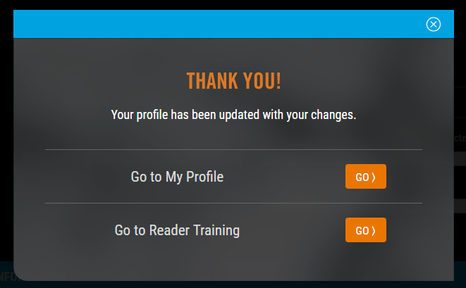

#### Navigation Actions

|  |  |  |  |
| --- | --- | --- | --- |
| **Area/Location** | **Action** | **Result** | **New or Same Tab/Window** |
| Profile Updated Modal | User selects “Go to My Profile” option | Modal closes and user is redirected to [My Profile Page](#_Feature:_My_Profile) | New |
| Profile Updated Modal | User selects “Go to Reader Training” option | Modal closes and user is redirected to Reader Training Page | Same |
| Profile Updated Modal | User clicks “X” in top-right corner of modal | Modal window closes and user is still on page where modal was prompted | Same |

### Feature: Core Training Complete/Survey Page

#### Business Rules

* User is navigated to Core Training Complete/Survey Page after finishing and clicking “Mark Complete” on last slide of Module 3 training
* This content should refresh/display within the same window as the user was viewing module training, but the content will not be within the Module Player Pagecontent itself
* Single button at the bottom of the page should be labeled “Close and View Certificate”, unless user selects any of the Survey area responses—at this point the button label should change to read “Submit and View Certificate”
* Taking the survey is not mandatory.
* The HCP can take the survey as many times as he /she wants
* If user indicates a response to any of the survey questions, they should be flagged in the database somehow as “Responded” to the survey. This will inform the Reader Training Page’s “bar” display that shows once user completed Mods 1-3, to include the “Rate Training” button that allows user to submit survey feedback at a later time if they do not do so initially (see section for Reader Training Pagefor more detail on “Rate Training button)
* If user accesses Core Training Rate Training Page via the “Rate Training” button on the Reader Training Page, the following display changes should occur:
  + The top paragraph pertaining to receiving certificate should not be present
  + The button at the bottom of the page should now just read “Submit”
  + Once user clicks submit and survey data is captured, page refreshes to Reader Training Page
* ~~Survey will be added at the end of Module 4 and Module 5~~
  + ~~Content TBD~~

#### Screen Mockup

Core Training Complete/Survey Page – Display When Shown Initially (After Mod 3 Complete)  
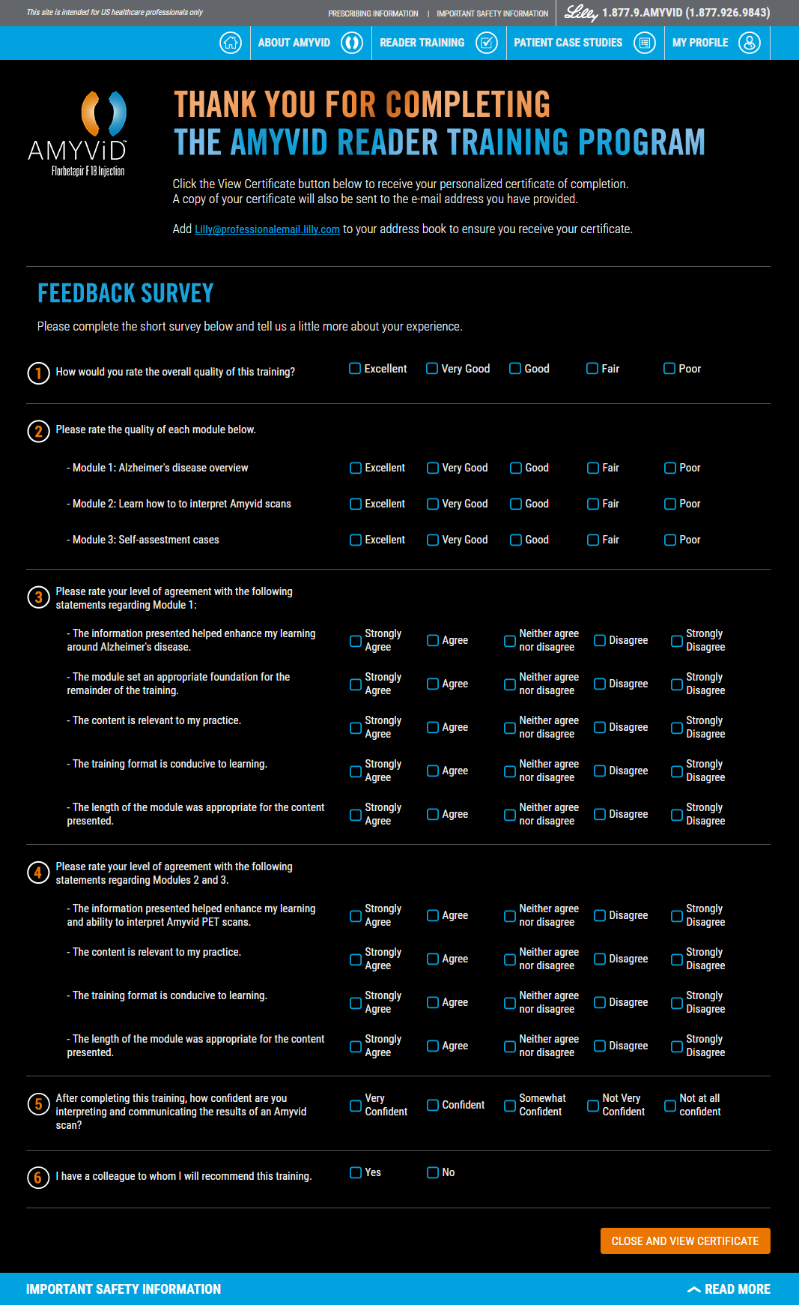

Core Training Complete/Survey Page – Button Label Change if User Clicks Any Response  


Core Training Complete/Rate Training Page – Display if Accessed Later via “Rate Training” button

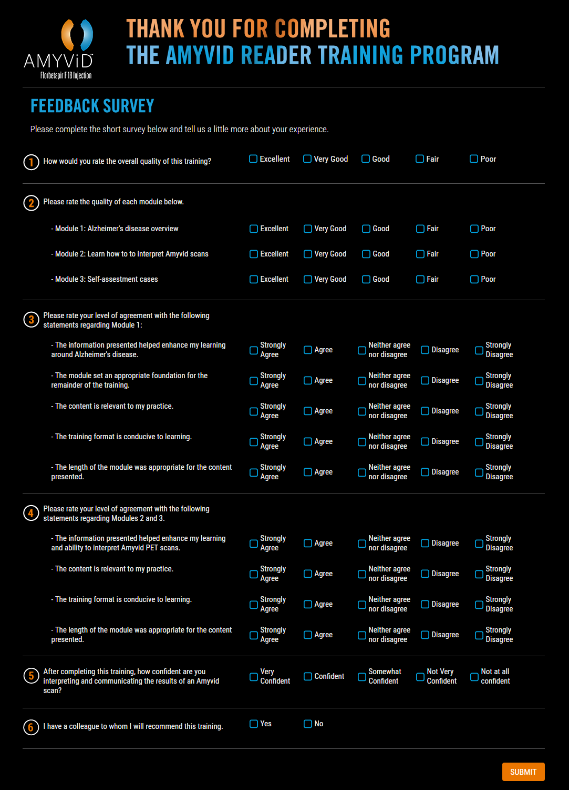

#### Navigation Actions

|  |  |  |  |
| --- | --- | --- | --- |
| **Area/Location** | **Action** | **Result** | **New or Same Tab/Window** |
| Core Training Complete/Survey Page | User clicks [Lilly@professionalemail.lilly.com](mailto:Lilly@professionalemail.lilly.com)hyperlink | Default mail client “compose” window is prompted via “mailto” hyperlink command | New |
| Core Training Complete/Survey Page | User clicks any of the response options to any survey question | Label of “Close and View Certificate” button changes to read “Submit and View Certificate” | Same |
| Core Training Complete/Survey Page | User clicks “Close and View Certificate” or “Submit and View Certificate” button | Page refreshes to redirect user to Reader Training Page (where “complete” blue banner should now display) | Same |
| Reader Training Page > Rate Training | User clicks “Rate Training” button | User is taken to Core Training Complete/Rate Training Page | Same |
| Reader Training Page > Rate Training | User clicks “Submit” button | Page refreshes to redirect user to Reader Training Page | Same |

## Within Module Features

### Feature: Module Player Page

#### Business Rules

* Navigation Header will remain locked at the top of page
* Navigation Header will include hyperlinked buttons to include:
  + Course Progress button (icon = *player-icons-courseprogress.png*)
  + Reference List button (icon = *player-icons-referencelist.png*)
  + Exit Module button (icon = *player-icons-exitplayer.png*)

#### Screen Mockup

Module Player Page  
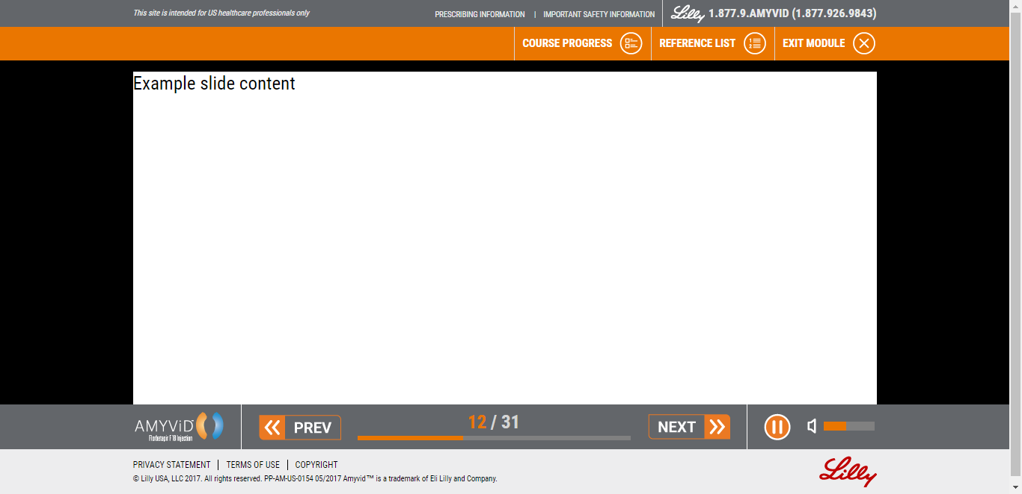

#### Navigation Actions

|  |  |  |  |
| --- | --- | --- | --- |
| **Area/Location** | **Action** | **Result** | **New or Same Tab/Window** |
| Navigation Header | User clicks “Course Progress” | Module Player – Course Progress menu is displayed | Same |
| Navigation Header | User clicks “Reference List” | Module Player – Reference List is displayed | Same |
| Navigation Header | User clicks “Exit Module” | Exit prompt is displayed | Same |
| Amyvid Logo | User clicks Amyvid Logo image | New Tab/Window opens with[Home Page](#_Feature:_Home_Page) | Same |
| Module Player Controls | User clicks “PREV” button | User is taken to the previous content screen | Same |
| Module Player Controls | User clicks “NEXT” button | User is progressed to the next content screen | Same |
| Module Player Controls | User clicks “PAUSE” button | Screen audio is paused | Same |
| Module Player Controls | User clicks VOLUME control | Audio volume is reduced or increased | Same |

### Feature: Module Player – Resume and Exit Prompts

#### Business Rules

* If user is either accessing a module they have already accessed before or attempts to exit a module in progress – a blue bar appears below navigation header with appropriate prompts
  + Resume prompt includes options to either restart course or resume where they left off
  + Exit prompt includes options to cancel or cancel the exit prompt/continue with module

#### Screen Mockup

RESUME Prompt  
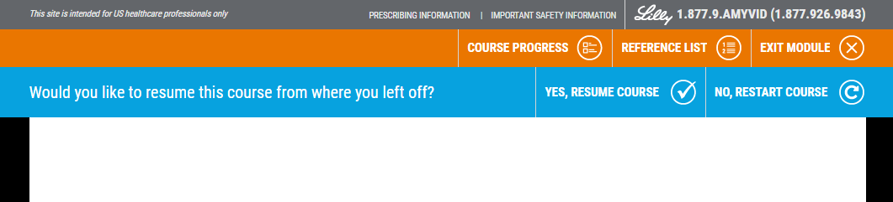

EXIT Prompt  
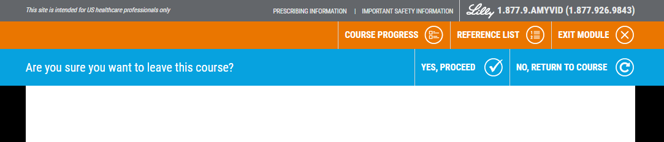

#### Navigation Actions

|  |  |  |  |  |  |  |  |
| --- | --- | --- | --- | --- | --- | --- | --- |
| **Area/Location** | | **Action** | | **Result** | | **New or Same Tab/Window** | |
| Reader Training Page | User clicks “Start” or “Review” for course they have already accessed before/left before completing | | Module opens for user and displays Resume promptto ask how user wants to proceed | | Same | |
| Module Page > Resume Prompt | User selects “Yes, resume course” | | Course content is resumed at place user left off | | Same | |
| Module Page > Resume Prompt | User selects “No, restart course” | | Course content is restarted at beginning | | Same | |
| Module Page | User clicks “Exit Module” | | Exit prompt is displayed | | Same | |
| Module Page > Exit Prompt | User clicks “Yes, proceed” | | Module is closed/user is redirected back to Reader Training Page | | Same | |
| Module Page > Exit Prompt | User clicks “No, return to course” | | Exit prompt goes away and user remains on page | |  | |

### Module Player – MarkComplete Functionality

#### Business Rules

* At the last page of ~~each~~ training module 3 only, there will be a mark complete button that must be selected in order to mark the course module as completed.
* When Module 3 is completed, it will be marked in the database that the user has completed the module and the Module 5 will become available to take.

#### Screen Mockup

Training Completion Page  
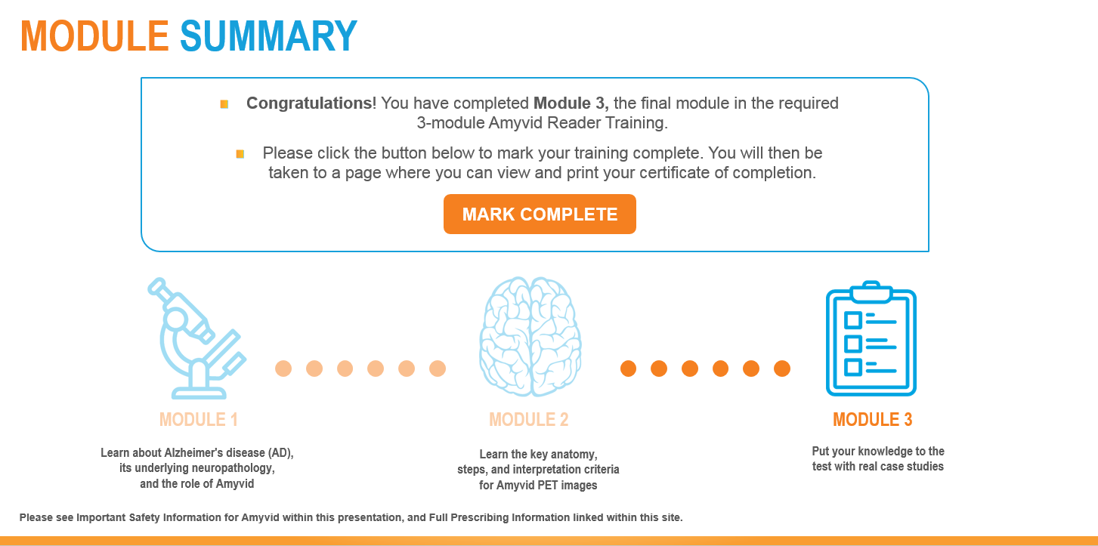

#### Navigation Actions

|  |  |  |
| --- | --- | --- |
| **Area/Location** | **Action** | **Result** |
| Last page of any module | User clicks “Mark Complete” | Training is marked complete in database and user is redirected back to Module Listing Page |
| Last page of Module 3 | User clicks “Mark Complete” | User is directed to post-training Core Training Complete/Survey Page |

### Module Player – CourseProgress Menu

#### Business Rules

* Users can view a “table of contents” list of screens for the module they are presently in
* Screenis marked as completewith a blue checkmark and bookmarked as it is viewed
* Section also marked as complete with a white checkmark as all screens within are viewed
* Users can jump around to previously viewed screens within the module they are presently in

#### Screen Mockup

Course Progress Menu

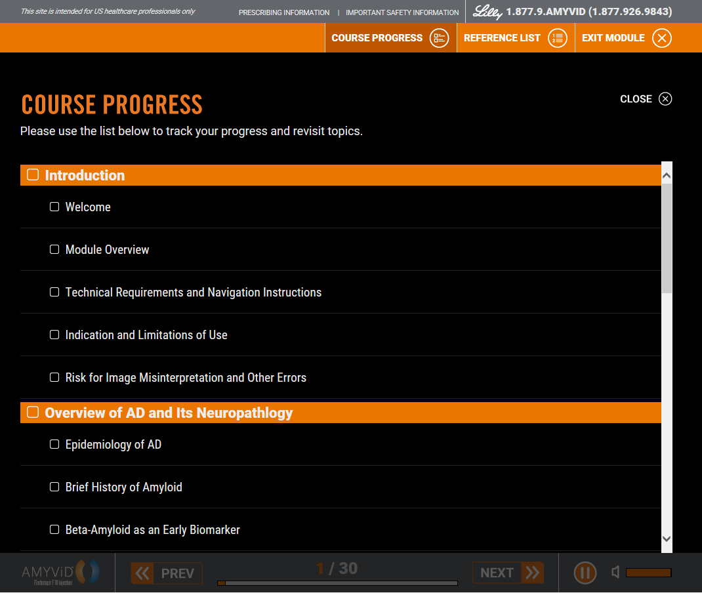

Course Progress Menu with Viewed Screens/Pages

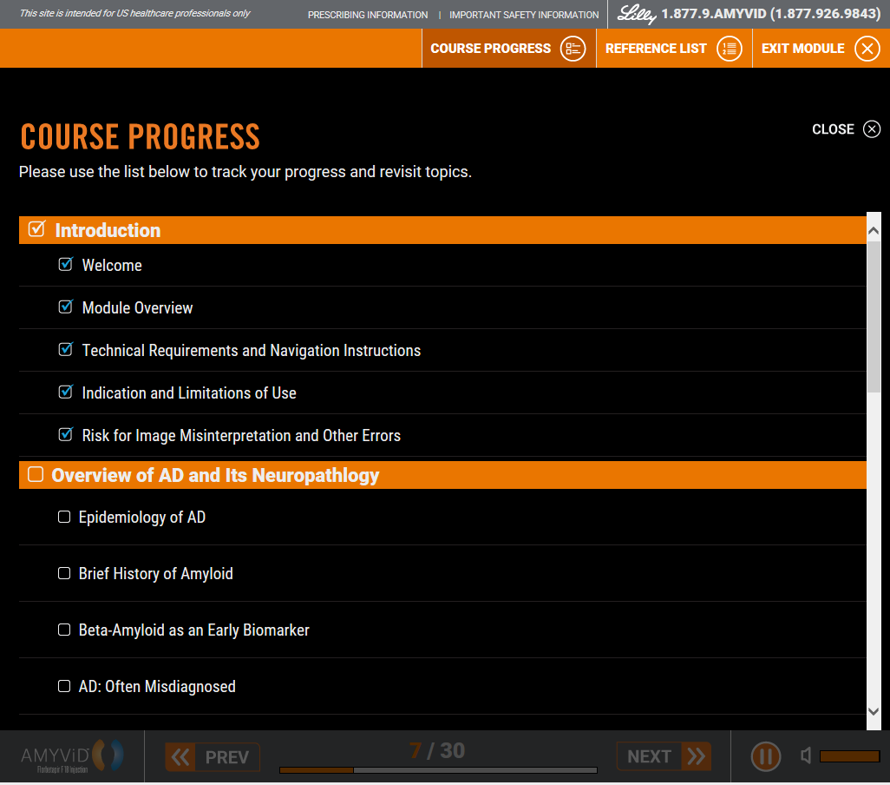

#### Navigation Actions

|  |  |  |
| --- | --- | --- |
| **Area/Location** | **Action** | **Result** |
| Course Progress Modal | User clicks “Close X” in upper-right corner of modal | Course Progress modal closes and user is returned to module page they were on when they clicked Course Progress button |
| Course Progress Modal Module Screen List | User clicks on previously viewed module screen | User is taken to the previously viewed module screen selected |

### Module Player – ReferenceList

#### Business Rules

* Rather than having page-specific reference functionality, will have a centralized static Reference List resource
* Reference List is alphabetical, static list

#### Screen Mockup

Reference List (1 of 2)  
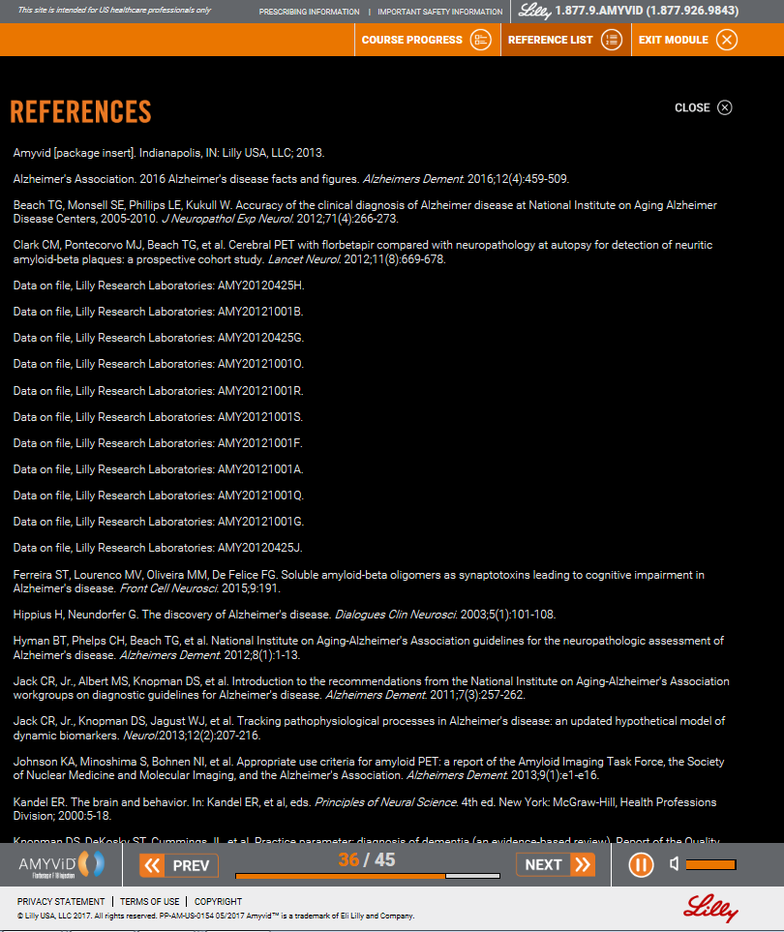

**Reference List 2 of 2**

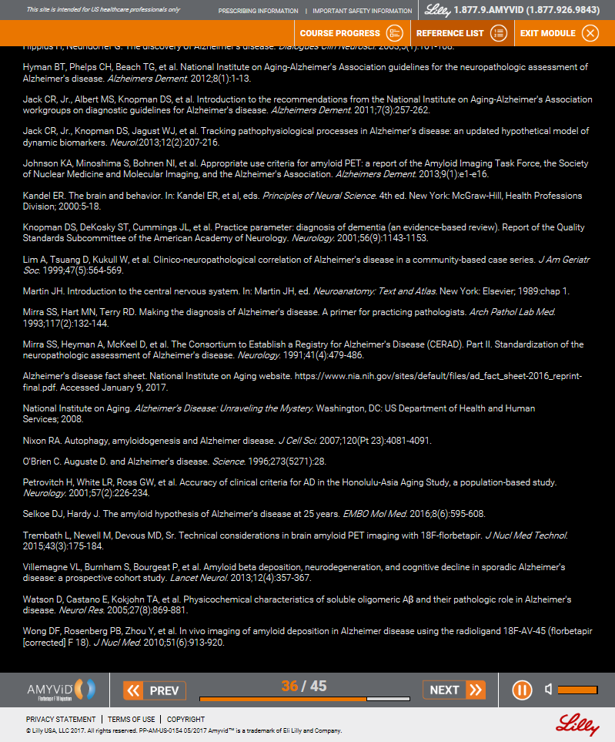

#### Navigation Actions

|  |  |  |
| --- | --- | --- |
| **Area/Location** | **Action** | **Result** |
| Reference List Modal | User clicks “Close X” in upper-right corner of modal | Reference List modal closes and user is returned to module page they were on when they clicked Reference List button |

### Bookmarking and Tracking Functionality

#### Business Rules

* Add tracking for first click response/attempt on cases within Module 3
  + JavaScript API Function: RESPONSEATTEMPT (var string)
* Add tracking within the modules to time how long a user spends on each page/slide
  + JavaScript API Function: TIMESPENT (var string)
* Add tracking within the modules to track individual and overall times a video was played within a module
  + JavaScript API Function: VIDEOSTATS (var string)
* Assumption is that module vendor will incorporate any new JavaScript API functions into module to integrate and capture all new details
* All the input to these functions should be JSON Strings as currently used in the Get and Save bookmark functions.
* These are functions they would need to call similar to current bookmarking functionality.

### Feature: Module Content

#### Module 1

#### Business Rules

* PC/Mac only: If there is audio for the screen, it should auto-play upon screen load
  + User has to click Play button to hear audio on iPad
* The following screen requires an iPad media query as content varies for iPad: Screen 1
* The following screens have animation
  + Chapter Title screens: 6, 12, 17, 23
    - Animation: starts with orange and blue bars in the center of the screen that move to the outer edge of screen and title appears between bars
  + Epidemiology of AD Screen 7
    - Animation: map graphic slides on to the screen from the left, then icons and text on the right side appear one by one from top to bottom
  + AD: Often Misdiagnosed Screen 10
    - Animation: Approximately 20% graphic/text appears on screen from top to bottom as if being “wiped” on
  + Amyvid: Mechanism of Action Screen 13
    - Animation: Text and divider lines automatically build, appearing one by one from top to bottom in a time sequenced
  + Amyvid was evaluated in 3 Pivotal Studies Screen 18
    - Animation: Reliable, Accurate, and Reproducible sections appear automatically, one by one from top to bottom in a time sequence
  + Streamlined Procedure Screen 24
    - Animation: Icons with text and arrows build, appearing one by one from left to right
* The following screens have digital interactivity:
  + Kinetics of Amyvid Brain Uptake and Washout Screen 28
    - Digital interaction: Timeframes need to be clickable and should show appropriate graph information when clicks. Timeframe “tab” should change from blue to orange when selected
      * Note: User does not have to click timeframes to advance to next screen

#### Module 2

#### Business Rules

* PC/Mac only: If there is audio for the screen, it should auto-play upon screen load
  + User has to click Play button to hear audio on iPad
* Demonstration Case and MIM Setup videos are mandatory to vide at least once and user cannot skip ahead (seek) within video or advance to next screen until video has been marked as complete/viewed
  + - Subsequent views will allow users to skip video and/or advance to next screen
* Practice Case videos should automatically play after user selects and answer and clicks “Done” button, regardless if answer is correct or incorrect
  + If user selects incorrect answer, videos are mandatory to view at least once and user cannot skip ahead (seek) within video or advance to next screen until video has been marked as complete/viewed
    - Subsequent views will allow users to skip video and/or advance to next screen
  + If user selects correct answer, user can advance to next screen without completing video
  + User can click Previous button to move to previous screens from screens with videos
  + Video can be maximized to full screen of module player using the button with two arrows in the bottom right of video player
    - User can use same button with two arrows to minimize the video screen out of full screen
* The following screens require an iPad media query as content varies for iPad: Screens 1, 34, 36-42
* The following screens have animation
  + Chapter Title screens: 6, 24, 33
    - Animation: starts with orange and blue bars in the center of the screen that move to the outer edge of screen and title appears between bars
* The following screens have digital interactivity:
  + Step 4: Review Every Transverse Image from the Bottom to the Top of the Brain Screen 16
    - Digital interaction: Brain scan images can be viewed using digital slider tool, moving from bottom to top vertically
    - This screen also includes a media query for IE in order to meet the following slider tool requirements (see screen mockup):
      * Slider thumb should be orange
      * Slider bar should fill in with blue as user scrolls up vertically and become clear as user scrolls back down
  + Common Challenges to Image Interpretation Screen 27
    - Digital interaction: Brain scan images can be viewed by moving the digital slider tool left and right
    - This screen also includes a media query for IE in order to meet the following slider tool requirements (see screen mockup):
      * Slider thumb should be orange
      * Slider bar should fill in with blue as user scrolls to the right and become clear as user scrolls back to the left
  + Common Challenges to Image Interpretation (Cont.) Screen 29
    - Digital interaction: User can switch between positive and negative scans using digital slider tool
    - This screen also includes a media query for IE in order to meet the following slider tool requirements (see screen mockup):
      * Slider thumb should be orange
      * Slider bar should fill in with blue as user scrolls to the right and become clear as user scrolls back to the left
  + Practice Case screens with Negative answer: Screens 36, 40, 41
    - Digital interactions:
      * If User clicks Done without selecting Positive or Negative, the following text is shown “**Please make a selection to continue.**”
      * User can select Positive or Negative radio button and click Done to submit answer
        + If Negative is selected, following text is shown “**That is correct.** This case is negative.”
        + If Positive is selected, following text is shown “**That is incorrect.** This case is negative.”
      * Video should auto-play once user selects answer and clicks Done button, regardless if answer is correct or incorrect
        + Video is mandatory to view for initial view
      * PC/Mac only: User can click on hyperlinked text “link to review practice_case_X” to access MIMviewer software
      * PC/Mac only: User clicks Login Information Reminder and modal pops up with login information and hyperlink to MIM download webpage
      * iPad only: User clicks Mobile MIM Installation Instructions and modal pops up with installation and login information
  + Practice Case screens with Positive answer: Screens 37, 38, 39, 42
    - Digital interactions:
      * User can select Positive or Negative radio button and click Done to submit answer
        + If Positive is selected, following text is shown “**That is correct.** This case is positive.”
        + If Negative is selected, following text is shown “**That is incorrect.** This case is positive.”
      * Video should auto-play once user selects answer and clicks Done button, regardless if answer is correct or incorrect
        + Video is mandatory to view for initial view
      * PC/Mac only: User can click on hyperlinked text “link to review practice_case_X” to access MIMviewer software
      * PC/Mac only: User clicks Login Information Reminder and modal pops up with login information and hyperlink to MIM download webpage
      * iPad only: User clicks Mobile MIM Installation Instructions and modal pops up with installation and login information

#### Screen Mockup

**Screen 16 Slider Tool**

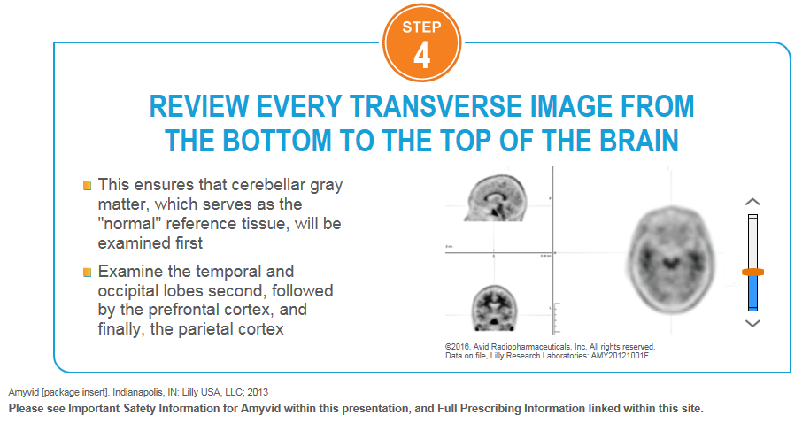

**Screen 27 Slider Tool**

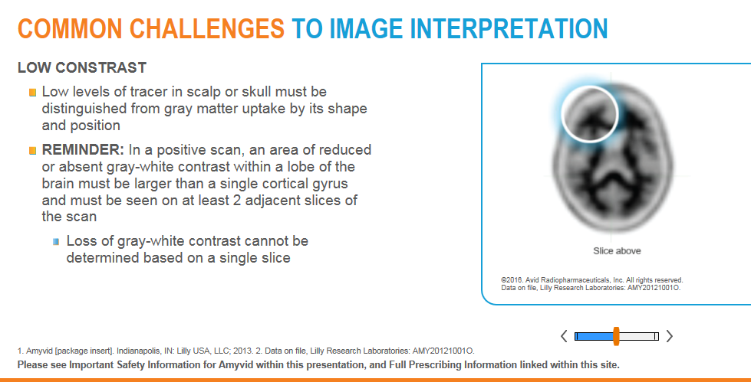

**Screen 29 Slider Tool**

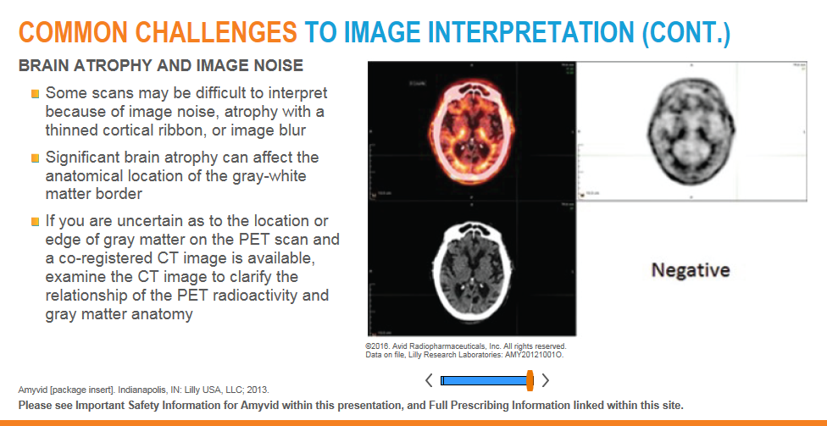

#### Navigation Actions

|  |  |  |
| --- | --- | --- |
| **Area/Location** | **Action** | **Result** |
| Module 2 > Practice Case MIM links | PC/Mac only: User clicks hyperlink “link to review practice_case_X” on Practice case screens | PC/Mac only: MIMviewer application opens separately and user is prompted to login |

#### Errors/Messages

|  |  |  |
| --- | --- | --- |
| **Area/Location** | **Action** | **Result** |
| Practice Case Screens | User clicks Done without selecting an answer of Positive or Negative | The following text is shown on screen below “Done” button: “Please make a selection to continue.” |

#### Module 3

#### Business Rules

* PC/Mac only: If there is audio for the screen, it should auto-play upon screen load
  + User has to click Play button to hear audio on iPad
* Self Assessment Case videos should automatically play after user selects and answer and clicks “Done” button, regardless if answer is correct or incorrect
  + If user selects incorrect answer, videos are mandatory to view at least once and user cannot skip ahead (seek) within video or advance to next screen until video has been marked as complete/viewed
    - Subsequent views will allow users to skip video and/or advance to next screen
  + If user selects correct answer, user can advance to next screen without completing video
  + User can click Previous button to move to previous screens from screens with videos
* Video can be maximized to full screen of module player using the button with two arrows in the bottom right of video player
  + User can use same button with two arrows to minimize the video screen out of full screen
* The following screens require an iPad media query as content varies for iPad: Screens 1, 5-24
* The following screens have digital interactivity:
  + Self Assessment Case screens with Negative answer: Screens 7, 8 ,9, 11,13, 15, 18, 19, 22, 23
    - Digital interactions:
      * If User clicks Done without selecting Positive or Negative, the following text is shown “**Please make a selection to continue.**”
      * User can select Positive or Negative radio button and click Done to submit answer
        + If Negative is selected, following text is shown “**That is correct.** This case is negative.”
        + If Positive is selected, following text is shown “**That is incorrect.** This case is negative.”
      * Video should auto-play once user selects answer and clicks Done button, regardless if answer is correct or incorrect
        + Video is mandatory to view for initial view
      * PC/Mac only: User can click on hyperlinked text “link to review self_assessment_case_X” to access MIMviewer software
      * PC/Mac only: User clicks Login Information Reminder and modal pops up with login information and hyperlink to MIM download webpage
      * iPad only: User clicks Mobile MIM Installation Instructions and modal pops up with installation and login information
  + Self Assessment Case screens with Positive answer: Screens 5, 6, 10, 12, 14, 16, 17, 20, 21, 24
    - Digital interactions:
      * User can select Positive or Negative radio button and click Done to submit answer
        + If Positive is selected, following text is shown “**That is correct.** This case is positive.”
        + If Negative is selected, following text is shown “**That is incorrect.** This case is positive.”
      * Video should auto-play once user selects answer and clicks Done button, regardless if answer is correct or incorrect
        + Video is mandatory to view for initial view
      * PC/Mac only: User can click on hyperlinked text “link to review self_assessment_case_X” to access MIMviewer software
      * PC/Mac only: User clicks Login Information Reminder and modal pops up with login information and hyperlink to MIM download webpage
      * iPad only: User clicks Mobile MIM Installation Instructions and modal pops up with installation and login information
  + Module Summary Screen 26
    - Digital interaction: User clicks “Mark Complete” button to mark the module and Core Reader Training complete in Hibbert database
      * User is navigated to Core Training Complete/Survey Page after finishing and clicking “Mark Complete” button
      * This content should refresh/display within the same window as the user was viewing module training, but the content will not be within the Module Player Page content itself

#### Navigation Actions

|  |  |  |
| --- | --- | --- |
| **Area/Location** | **Action** | **Result** |
| Module 3 > Self Assessment Case MIM links | PC/Mac only: User clicks hyperlink “link to review self_assessment_case_X” on Self Assessment case screens | PC/Mac only: MIMviewer application opens separately and user is prompted to login |
| Module 3 > Module Summary Screen 26 | User clicks “Mark Complete” button | User is navigated to Core Training Complete/Survey Page |

#### Errors/Messages

|  |  |  |
| --- | --- | --- |
| **Area/Location** | **Action** | **Result** |
| Self Assessment Case Screens | User clicks Done without selecting an answer of Positive or Negative | The following text is shown on screen below “Done” button: “Please make a selection to continue.” |

#### Module 5

#### Business Rules

* PC/Mac only: If there is audio for the screen, it should auto-play upon screen load
  + User has to click Play button to hear audio on iPad
* Videos are **not** mandatory
  + User can click Previous button to move to previous screens from screens with videos
  + Video can be maximized to full screen of module player using the button with two arrows in the bottom right of video player
    - User can use same button with two arrows to minimize the video screen out of full screen
* The following screens require an iPad media query as content varies for iPad: Screens 1, 8-27
* The following screens have digital interactivity:
  + Challenge Case Dashboard: Screen 7
    - Blue numbered circle icons represent Challenge Cases that users have not yet attempted to answer
      * User may view case but has not selected an answer and clicked “Done” button
    - Numbered circle icon changes to red numbered circle icon if user answers Challenge Case incorrectly
    - Numbered circle icon changes to green numbered circle icon with checkmark if user answers Challenge Case correctly
    - Dashboard will represent last answer user submits eg. If user initially answers Challenge Case incorrectly and then immediately submits correct answer, Dashboard will show green numbered circle icon with checkmark to represent last (correct) answer
  + Challenge Case screens with Negative answer: Screens 8, 12, 16, 19, 20, 23, 25
    - Digital interactions:
      * If User clicks Done without selecting Positive or Negative, the following text is shown “**Please make a selection to continue.**”
      * User can select Positive or Negative radio button and click Done to submit answer
        + If Negative is selected, following text is shown “**That is correct.** This case is negative.”
        + If Positive is selected, following text is shown “**That is incorrect.** This case is negative.”
      * Video should auto-play once user selects answer and clicks Done button, regardless if answer is correct or incorrect
      * PC/Mac only: User can click on hyperlinked text “link to review challenge_case_X” to access MIMviewer software
      * PC/Mac only: User clicks Login Information Reminder and modal pops up with login information and hyperlink to MIM download webpage
      * iPad only: User clicks Mobile MIM Installation Instructions and modal pops up with installation and login information
  + Challenge Case screens with Positive answer: Screens 9, 10, 11, 13, 14, 15, 17, 18, 21, 22, 24 ,26, 27
    - Digital interactions:
      * User can select Positive or Negative radio button and click Done to submit answer
        + If Positive is selected, following text is shown “**That is correct.** This case is positive.”
        + If Negative is selected, following text is shown “**That is incorrect.** This case is positive.”
      * Video should auto-play once user selects answer and clicks Done button, regardless if answer is correct or incorrect
      * PC/Mac only: User can click on hyperlinked text “link to review challenge_case_X” to access MIMviewer software
      * PC/Mac only: User clicks Login Information Reminder and modal pops up with login information and hyperlink to MIM download webpage
      * iPad only: User clicks Mobile MIM Installation Instructions and modal pops up with installation and login information

#### Navigation Actions

|  |  |  |
| --- | --- | --- |
| **Area/Location** | **Action** | **Result** |
| Module 5 > Challenge Case MIM links | PC/Mac only: User clicks hyperlink “link to review challenge_case_X” on Challenge case screens | PC/Mac only: MIMviewer application opens separately and user is prompted to login |
| Module 5 > Challenge Case Dashboard | User clicks on any icon with circled number or circled number and checkmark | User is navigated to the corresponding Challenge Case |
| Module 5 > Challenge Case Screens | User clicks “Return to Dashboard” button | User is navigated back to Challenge Case Dashboard (Screen 7) |
| Module 5 > Challenge Case Screens > Login Information Reminder Modal | Within Login Information Reminder modal, user clicks “MIMcloud Viewer” link | PC/Mac only: User is taken to external link: <https://mim-cloud.appspot.com/#installviewer> |

#### Errors/Messages

|  |  |  |
| --- | --- | --- |
| **Area/Location** | **Action** | **Result** |
| Challenge Case Screens | User clicks Done without selecting an answer of Positive or Negative | The following text is shown on screen below “Done” button: “Please make a selection to continue.” |

# Site-Related Emails

### 3 Day Email Reminder

#### Business Rules

* Will be sent to users 3 days after starting the ORT training and not completing it
* Email content to include:

#### Screen Mockup

### 7 Day Email Reminder

#### Business Rules

* Will be sent to users 7 days after starting the ORT training and not completing it
* Email content to include:

#### Screen Mockup

### Welcome/New Registration E-mail

#### Business Rules

* Will be sent to users after submitting registration of a new account via the Registration Page
* Notification should hit users’ inbox within 30 seconds of registration being completed
* Email content to include:
  + A welcome message for registering
  + An authentication link that takes user to authentication page within site and redirects them to the Module Listing Page (first page of the training/account access)

#### Screen Mockup

Example from UK Site

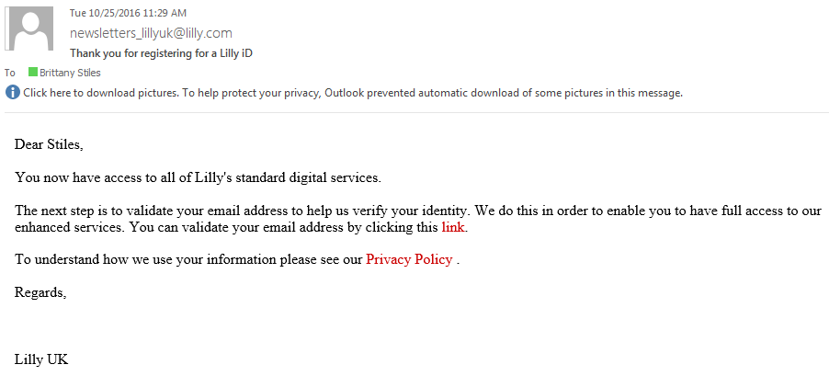

### Forgotten Password Email

#### Business Rules

* Will be sent to users after submitting email via the Forgot Password Request Page
* Notification should hit users’ inbox within 30 seconds of Forgot Password Request Page submission
* Email content to include:

#### Screen Mockup

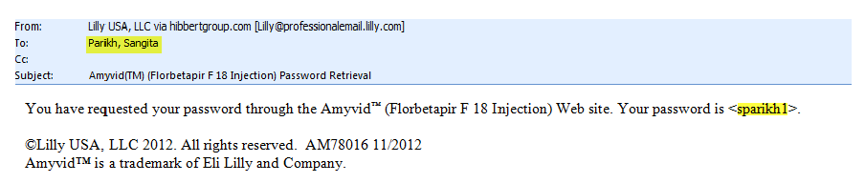

### Core Training Complete/Certificate Email

#### Business Rules

* When the last Module is completed, the user will be provided their certificate:
  + Certificate will be personalized with the user’s first and last name.
  + Certificate will be attached to the training completion email.
* Notification should hit users’ inbox within 30 seconds of training being marked complete
* Email content to include:

#### Screen Mockup

**Core Training Complete/Certificate Email**

# Existing Site Metrics/Reporting

### Feature: Reader Training Completion Report

#### Online Training Tab

##### Business Rules

* Will be generated weekly
* Will include the following columns:
  + First Name
  + Last Name
  + Address1
  + Address2
  + City
  + State
  + Zip Code
  + Specialty
  + Week Completed

##### Screen Mockup



#### 2012 Live Training and Trials Tab

##### Business Rules

* Will be generated weekly
* Added directly to report from Amyvid team
* Will include the following columns:
  + Event Title/Location/Date
  + First Name
  + Last Name
  + Degree
  + Zip Code

##### Screen Mockup

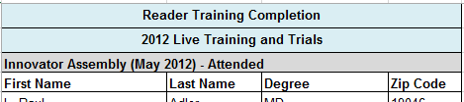

#### 2013 Live Trainings Tab

##### Business Rules

* Will be generated weekly
* Added directly to report from Amyvid team
* Will include the following columns:
  + Event Title/Location/Date
  + First Name
  + Last Name
  + Degree
  + Zip Code

##### Screen Mockup

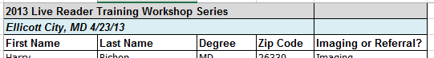

#### 2016 Live Trainings Tab

##### Business Rules

* Will be generated weekly
* Added directly to report from Amyvid team
* Will include the following columns:
  + Event Title/Location/Date
  + First Name
  + Last Name
  + Degree
  + Zip Code

##### Screen Mockup

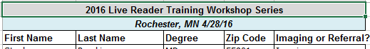

#### Totals Tab

##### Business Rules

* Will be generated weekly
* Added directly to report from Amyvid team
* Will include Total Number of Trainings per the following:
  + Online
  + Live Workshops (Regionals + Congresses)
  + Innovators Assembly
  + Clinical Trials
  + Overall

##### Screen Mockup

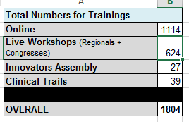

### Feature: Module Tracking Report

#### Module 1 Tab

##### Business Rules

* Will be generated monthly
* Will include the following:
  + # of users who attempted module
  + # of users who did not complete module
    - # of users left on page X of Module (1 – 44)

##### Screen Mockup



#### Module 2 Tab

##### Business Rules

* Will be generated monthly
* Will include the following:
  + # of users who attempted module
  + # of users who did not complete module
    - # of users left on page X of Module (1 – 26)

##### Screen Mockup



#### Module 3 Tab

##### Business Rules

* Will be generated monthly
* Will include the following:
  + # of users who attempted module
  + # of users who did not complete module
    - # of users left on page X of Module (1 – 27)
  + Use case #/ Q ID: 1 thru 20
    - Response
      * # users answered ‘Positive’:
      * # users answered ‘Negative’:
    - Result (Ie, Of the total who answered Use Case, how many got it right)
    - Latency

##### Screen Mockup



### Feature: Email Report

#### Reminder Email (3 day) Report Tab

##### Business Rules

* Will be generated monthly
* Will include the following:
  + Total # of users who received 3 day email:
    - Module 1
    - Module 2
    - Module 3
  + Total # of users who received 3 day email and returned, but have NOT completed the training yet:
    - Module 1
    - Module 2
    - Module 3
  + Total # of users who received 3 day email and completed the training:
    - Module 1
    - Module 2
    - Module 3

##### Screen Mockup



#### Reminder Email (7 day) Report Tab

##### Business Rules

* Will be generated monthly
* Will include the following:
  + Total # of users who received 7 day email:
    - Module 1
    - Module 2
    - Module 3
  + Total # of users who received 7 day email and returned, but have NOT completed the training yet:
    - Module 1
    - Module 2
    - Module 3
  + Total # of users who received 7 day email and completed the training:
    - Module 1
    - Module 2
    - Module 3

##### Screen Mockup



#### Accuracy Satisfaction tab

##### Business Rules

* Will be generated monthly
* Module 3 Accuracy/Satisfaction %
* Accuracy Prior to 2017
  + - % Right on each Question – Question 1 thru 20
    - % Right on questions in TOTALITY for Module 3
  + Accuracy in 2017 (Current Year) using first click element when available
    - % Right on each Question – Question 1 thru 20
    - % Right on questions in TOTALITY for Module 3
  + Accuracy Program Release to Date (include both data prior to 2017 + current year)
    - % Right on questions in TOTALITY for Module 3
  + Satisfaction % (based on answer in Survey Question #1)
    - Satisfaction % Prior to 2017
    - Satisfaction % in 2017 (Current Year)
    - Satisfaction % Total

##### Screen Mockup

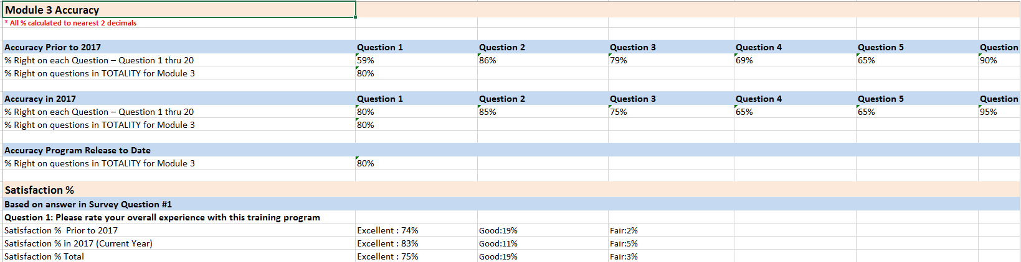

### Feature: Live Agent Technical Support Report

#### Live Agent Technical Support Report

##### Business Rules

* Easily identify nature of cal
* Easily identify team the call was escalated to
* Will be generated monthly
* Will include the following:
  + Caller ID
  + Seq #
  + Call Date
  + Call Time
  + First
  + Last
  + Phone
  + Email
  + Call Type
  + Browser
  + Browser version
  + Menu Items
  + Module
  + Check Flash
  + Module 1 Ending
  + Module 2 Ending
  + Module 3 Ending
  + MIM
  + MIM Concern
  + MIM Sub Concern
  + Transfer
  + Certificate concern
  + Registration/Log-in Issues
  + Registration Ending
  + FAQ (General/Technical Questions)
  + Sub FAQ
  + FAQ Ending
  + Adverse Events
  + Product Complaints
  + Medical Questions
  + Product Complaints Ending
  + Medical Questions Ending

# Admin Portal/Lookup Tool/Analytics Tool: Enhanced Integration for Reporting

#### Admin Portal

##### Business Rules

* Admin Portal consisting of Lookup Tool and Analytics Tool will only be visible after user signs in, on Navigation header
  + Lookup Tool and Analytics Tool will only be accessible by Internal Lilly Users and Hibbert stakeholders
  + Admin should consist of Jack Urbanski, Sarah Elizabeth Foster, Kyle Brenden Moore and internal Hibbert stakeholders

#### Lookup Tool

##### Business Rules

* Look up search function to check if user information and if user has completed training; include Overall training and LRT and ORT training
  + Ability to review/resend/generate Certificate seamlessly within Lookup Tool
  + Admin User must be able to access certificate no matter when training has been completed. If user has completion date please allow certification creation in new certificate/HTML (new format)
* Upon Clicking Lookup tool, admin will be able to search on the following record attributes
  + First name
  + Last name
  + Email Address
  + Primary Specialty
  + Street Address 1
  + Street Address 2
  + City
  + State
  + Zip
* Upon clicking “Look Up” button for a particular user, a results screen will render a quick view and will include
  + Completed
    - If Yes (modules 1 – 3 completed) the line item will appear green
    - If No (modules 1 – 3 not completed) the line item will appear red
  + First name
  + Last name
  + Email
  + Link to download certificate (if applicable)
* Upon selecting a line item/record on the quick view results page the a detail view page will render for that particular record including
  + First name
  + Last name
  + Email Address
  + Primary Specialty
  + Street Address 1
  + Street Address 2
  + City
  + State
  + Zip
  + Certificate Download button

#### Analytics

##### Business Rules

* Analytics will not include users with the domains
* @avanthc.com
* @dwainc.com
* @dwahcg.com
* @hibbertgroup.com
* @lilly.com
* When the Analytics button is clicked the Dashboard reporting will be available within 3 tabs
  + Reader Training Completion Report
    - Will include the following:
      * Side by side comparison of ‘Live event’ reader training VS. ‘online’ reader training Totals
        + Historical (2012, 2013, and 2016) vs Current Year
      * Show total percentage of users that have completed Practice Case Modules (4 & 5) that includes break out between ORT vs LRT
  + Module Accuracy/Survey
    - Will include the following:
      * Breakdown of Module 3 Accuracy
        + % Right vs Wrong on Case 1 thru 20
      * Breakdown of Module 5 Accuracy
        + % Right vs Wrong on Case 1 thru 20
      * Drop down to toggle between Module 3/5
      * Drop down to toggle between First Click Answer and Overall Answer
      * Survey response/percentage for questions 1, 2, & 5
        + Survey Question 1: How would you rate the overall quality of this training?

# of users who answered 'Excellent':

# of users who answered 'Very Good':

# of users who answered 'Fair':

# of users who answered 'Poor':

* + - * + Survey Question 2: Please rate the quality of each module below.

Module 1: Alzheimer’s disease overview

# of users who answered 'Excellent':

# of users who answered 'Very Good':

# of users who answered 'Fair':

# of users who answered 'Poor':

Module 2: Learn how to interpret Amyvid scans

# of users who answered 'Excellent':

# of users who answered 'Very Good':

# of users who answered 'Fair':

# of users who answered 'Poor':

Module 3: Self-assessment cases

# of users who answered 'Excellent':

# of users who answered 'Very Good':

# of users who answered 'Fair':

# of users who answered 'Poor':

* + - * + Survey Question 5: After completing this training, how confident are you interpreting and communicating the results of an Amyvid scan?

# of users who answered 'Very confident':

# of users who answered 'Confident':

# of users who answered 'Somewhat confident':

# of users who answered 'Not very confident':

# of users who answered 'Not at all confident':

* + Module Stats/Tracking
    - Drill down by State to specific user for:
      * Module Accuracy
      * Time spent on Modules
      * Time spent on Videos

##### Screen Mockup

# Non-Functional Requirements

* In order to ensure expected behavior the site should adhere to the following compatibility guidelines
  + Must be compatible with Java version 6 Update 31 or higher
  + HTML5 may be used provided alternate content is displayed for non-compatible browser versions.
  + Flash and Silverlight content must not be used
* JW Player will be used to play videos (MP4 video files)
* Videos will need to default to high-definition in order to appropriately view all small, footnote content for compliance reasons
  + Will need to include option for users with low-resolution monitors to switch from HD to low-def
* Security will be controlled on a granted or denied basis with no security “levels” defined
* Appropriate coding must be applied so that web content is not cached by search engines.

## Hardware and Software Support Environments

* The database will be hosted on Oracle/Sun Microsystems series UNIX servers running the Solaris operating system for websites.
* Application hosting is supported using TomCat web servers across multiple servers load balanced via multiple F5 BIG-IP traffic managers.
  + Content delivery network is integrated with the TomCat hosted environment supporting digital content hosting and delivery over a multi-tiered server infrastructure interconnected with a minimum of 1gb of network connectivity
* Applications are developed using Java technology (Spring & Struts frameworks, Hibernate,  XML, JavaScript, Restful & SOAP web services) and Oracle RDBMS.

Technology Versions

|  |  |
| --- | --- |
| Java Framework | v. 1.6 |
| Oracle | 11.2.X |
| TomCat | v. 7.x |
| Unix | SunSolaris v. 2.10 |
| F5 BIG-IP | BIG-IP 10.X |

### Browser/Operating System Constraints

* Microsoft IE 10 or higher
* Safari version 9.x or higher
* Mozilla Firefox 50
* Google Chrome 55
* iOS Safari 9.x or higher
* Must be compatible with Java version 6 Update 31 or higher
* HTML5 may be used provided alternate content is displayed for non-compatible browser versions.
* Flash and Silverlight content must not be used

## Tablet Compatibility

* Site must be compatible for viewing on iPad
* Site UI content is limited to 1024px in width to facilitate proper iPad viewport display

## Performance

* Approximate file size for each video will be 50-70 MB
* The system shall complete a transaction in average of 10 seconds
* The system shall accommodate a minimum number of 25-50 users at any given time

## Security and Compliance

* Users must log-in with their AmyvidHCP.com username/password - from online reader trainings (ORTs) or Live Reader Training events OR create a new log-in if they have not previously accessed any of these resources
* Access is given on a grant or deny basis. Levels of access and administrative UI are not within the project scope.
* Content must be accessed via secure site protocol (SSL). (https://)
* Personally identifiable information (PII) must be encrypted in database.

## Usability

* The system shall be usable by entry-level PC users
* Color scheme/design considerations from Area 23

## System Interaction

* Allow training content access via user’s pre-existing ORT account log-in or create new
* JW player will be embedded in the system. No additional plug-ins will be used/needed

# Review and Approvals

|  |  |  |  |
| --- | --- | --- | --- |
| Name | Role/Department | Date | Comments |
|  |  |  |  |